OPENING SESSION OF THE SECOND PICDA INTERNATIONAL CONFERENCE
Opening Prayers: The Conference commenced at 11.05am with an Opening Prayer offered by Dr. Oluwatobi Johnson.
National Anthem: The first stanza of the National Anthem was rendered.
Introduction of Dignitaries and Guests: Among the dignitaries introduced included Professor Musa Dankyau, Deputy Vice Chancellor, Bingham University, Ms. Julie Sanda, DG- PSPBA, the representative of the Governor of Plateau State; Venerable Jibrailu Dabong, Senior Special Assistant on Christian Religious Matters, and the representative of the Governor of Nasarawa State; Professor Abiodun Adeniyi(Registrar, Baze University), Professor Sunday Ochoche( Former DG, Institute for Peace and Conflict Resolution), Ambassador Bulus Lolo, Cuban Ambassador Miriam Morales Palmero, Portuguese Ambassador Paulo Santos, Colombian Ambassador Marisel Romero Castillo, Professor Tijani Muhammad-Bande, GCON, Professor Hassan Saliu, President of Nigerian Political Science Association(NPSA), Ambassador Joe Keshi, President of Association of Retired Career Ambassadors of Nigeria(ARCAN); Chief Akin Arikawe, retired Federal Permanent Secretary, and the representative of the Chairman, Council for Retired Federal Permanent Secretaries(CORFEPS), and Mr. Japh Nwosu, among others.
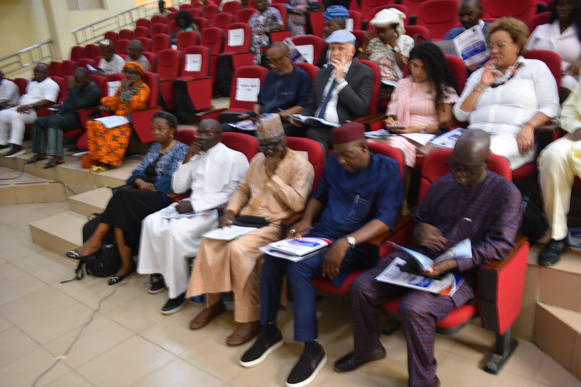
WELCOME ADDRESS BY DR. OLUSHOLA JOHN MAGBADELO, DIRECTOR, AMBASSADOR BULUS LOLO CENTRE FOR DIPLOMACY, CONFLICT, PEACE AND PLURAL STUDIES (ABLC),BINGHAM UNIVERSITY.
The Director of ABLC said it was his honour to welcome attendees to the 2nd PICDA International Conference hosted by ABLC, Bingham University. He explained that PICDA meant Political Instability and Crises of Development in Africa, and noted the Centre emerged from the first conference to foster research and debate on governance, conflict, and diplomacy. He stated this year’s theme addressed climate change, insecurity, terrorism, and governance crises, which he described as intertwined threats to Africa’s stability.
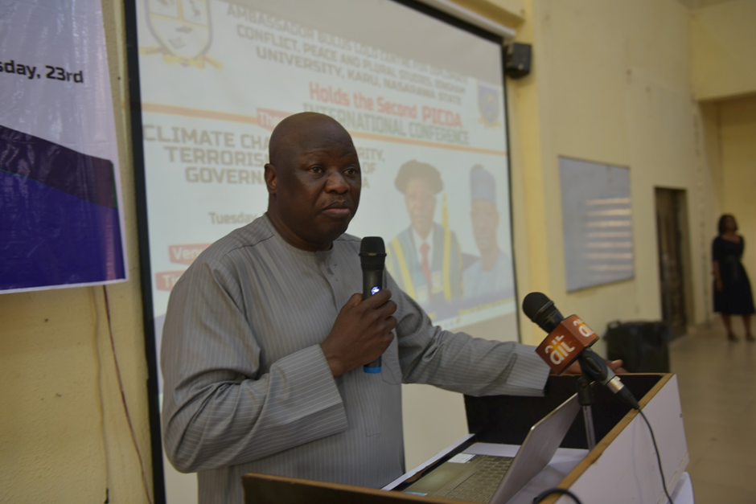
The Director, ABLC, Dr. Olushola John Magbadelo, delivering a Welcome Address
He announced Professor Tijani Muhammad-Bande would deliver the lead paper and chair a Nonalignment roundtable, while expressing regrets that contrary to an earlier agreement to get Professor Christian Kaunert to address participants via Zoom due to his ill-health which prevented him from travelling to Nigeria, the latest disappointing development was that he had been fully hospitalized as a result of the severity of his condition. He prayed that God should grant him perfect healing and speedy recovery. He thanked dignitaries and Nasarawa and Plateau State governments, and outlined two roundtables plus nearly seventy papers. He expressed conviction that the conference would yield proceedings, a communique, and a journal to help build a secure, prosperous Africa (See Annex I).
OPENING ADDRESS BY THE VICE CHANCELLOR, BINGHAM UNIVERSITY, PROFESSOR HURUNA KUJE AYUBA, REPRESENTED BY THE DEPUTY VICE CHANCELLOR, PROFESSOR MUSA DANKYAU.
Delivering the address of the Vice Chancellor, Professor Haruna Kuje Ayuba, the Deputy Vice Chancellor, Professor Dankyau welcomed attendees to Bingham University, Karu, Nigeria, for the 2nd PICDA International Conference, organized by the Ambassador Bulus Lolo Centre for Diplomacy, Conflict, Peace and Plural Studies (ABLC). He noted that ABLC, established just a year earlier, had already emerged as a leading hub for dialogue, research, and policy development on diplomacy, insecurity, conflict resolution, and plural studies in Nigeria. He recalled that ABLC, in partnership with the Department of Political Science, had hosted the 1st PICDA Conference in 2025. He added that the Centre had subsequently secured funding from the Konrad Adenauer Foundation to train 45 Bingham University staff in diplomacy and conflict resolution. He expressed satisfaction that the Centre had again convened experts to examine climate change, insecurity, terrorism, and governance crises in Africa. Professor Ayuba described the nexus of these issues as complex and mutually reinforcing. 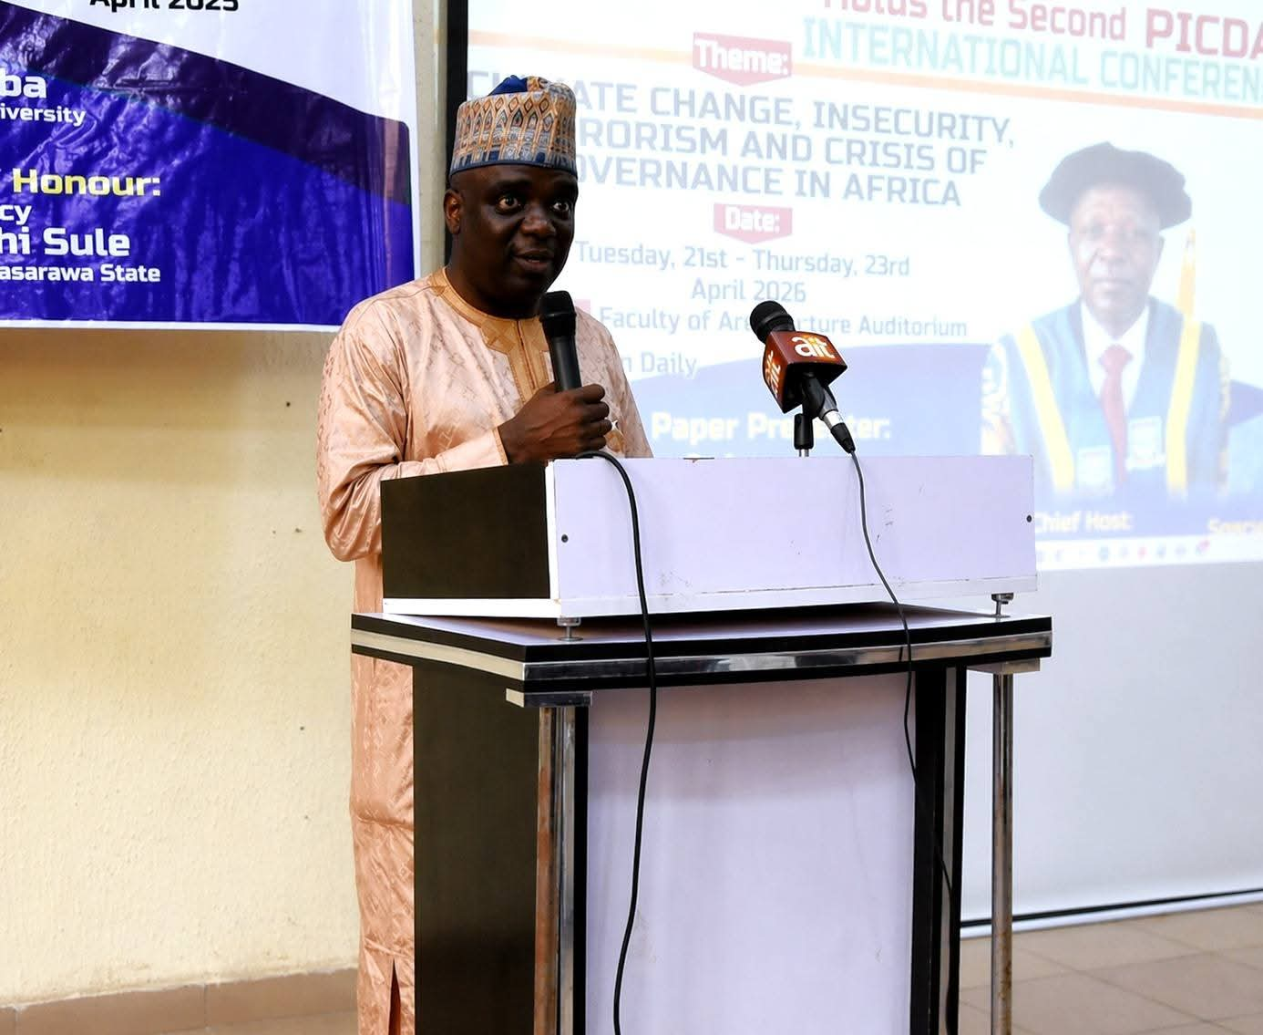
The Deputy Vice Chancellor, Professor Musa Dankyau, represented Professor Haruna Kuje Ayuba, Vice Chancellor, Bingham University, Karu.

He said climate change acted as a threat multiplier, displacing communities and intensifying resource competition, while insecurity and terrorism exploited governance vacuums and vulnerable populations.
He observed that weak institutions, corruption, and poor leadership undermined responses and perpetuated cycles of crisis, thereby threatening national stability and social cohesion. He emphasized the need for integrated strategies that combined environmental sustainability, security, and governance reforms. Nonetheless, he pointed out that these challenges also offered opportunities for growth and innovation. He argued that scholars, policymakers, and practitioners had a duty to engage in interdisciplinary dialogue and craft actionable solutions for a more just and sustainable future. He thanked Dr. Olushola John Magbadelo and the Local Organizing Committee for their dedication, and honoured Ambassador Bulus Lolo, whose diplomatic contributions had inspired the Centre’s creation. In closing, he appreciated Excellences, Royal Majesties, the Diplomatic Corps, speakers, and participants, noting that their presence underscored the value of cooperation in tackling complex challenges. He expressed hope for a productive and engaging conference (See Annex II).
ADDRESS BY THE EXECUTIVE GOVERNOR OF NASARAWA STATE, ENGR. ABDULLAHI SULE, DELIVERED BY VENERABLE JIBRAILU YARIMA DABONG, SENIOR SPECIAL ASSISTANT ON CHRISTIAN AFFAIRS.
The SSA to the Governor of Nasarawa State, Venerable Jibrailu Yarima Dabong, said he was delighted to attend the 2nd PICDA Conference hosted by ABLC at Bingham University, domiciled in his state. He commended the University’s vision in establishing ABLC and praised the conference theme on climate change, insecurity, terrorism, and governance crises as timely.
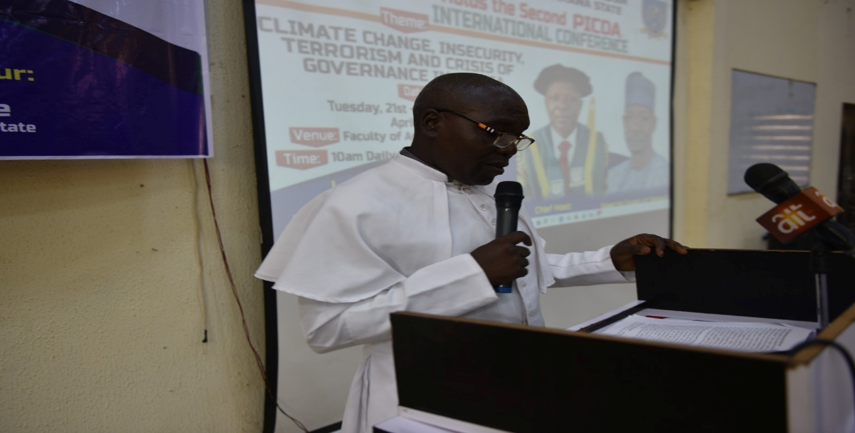
The SSA to the Governor of Nasarawa State, Venerable Jibrailu Yarima Dabong representative of the Executive Governor of Nasarawa State, Engr. Abdullahi Sule.
He described climate change as a “threat multiplier” fueling farmer-herder conflicts in Nasarawa and the Middle Belt. He noted that governance deficits enabled terrorism, stressing his administration’s commitment to security, healthcare, education, and industry. He lamented that scarce resources were diverted to military operations rather than resilience. He urged proactive, faith-driven strategies integrating climate adaptation and security. Representing Governor Abdullahi Sule, he declared the conference open and wished delegates success (See Annex III).
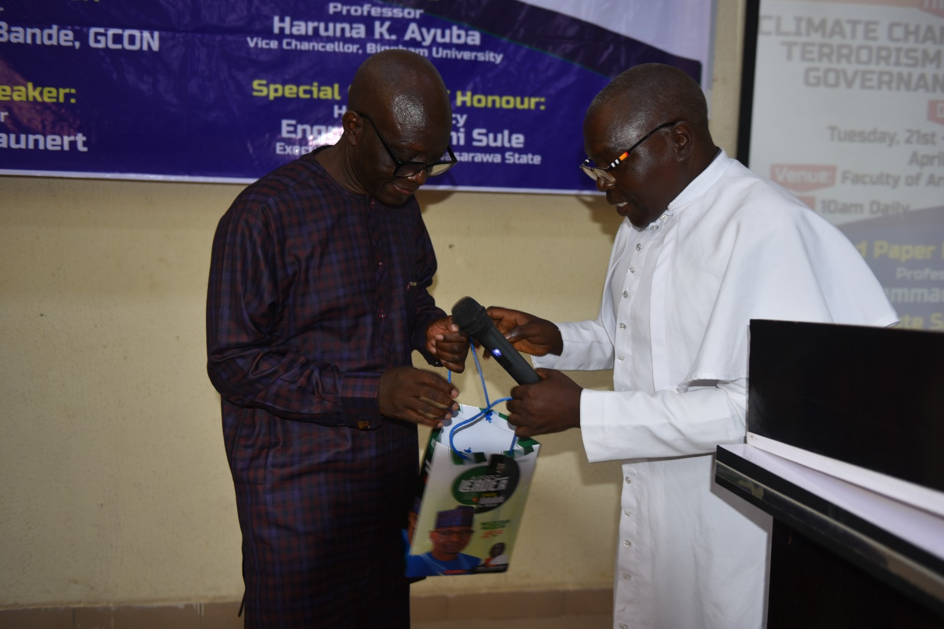
The SSA to Governor Abdullahi Sule presented a gift to the ABLC, Bingham University which was received by Amb. Bulus Lolo.

AN ADDRESS BY THE EXECUTIVE GOVERNOR OF PLATEAU STATE, BARR. CALEB MUTFWANG, CON, REPRESENTED BY Ms. JULIE SANDA, DIRECTOR GENERAL, PLATEAU STATE PEACEBUILDINF AGENCY.
The Representative of the Plateau State Governor conveyed warm greetings from the Government and people of Plateau State and thanked Bingham University and ABLC for the invitation. According to Madam Julie Sanda, the Governor said conferences often produced communiqués without changing realities, but stressed that the theme on climate change, insecurity, terrorism, and governance crises reflected overlapping challenges faced daily. She noted that Africa contributed under 4% of global emissions yet suffered severe climate vulnerability, causing displacement and governance pressure.

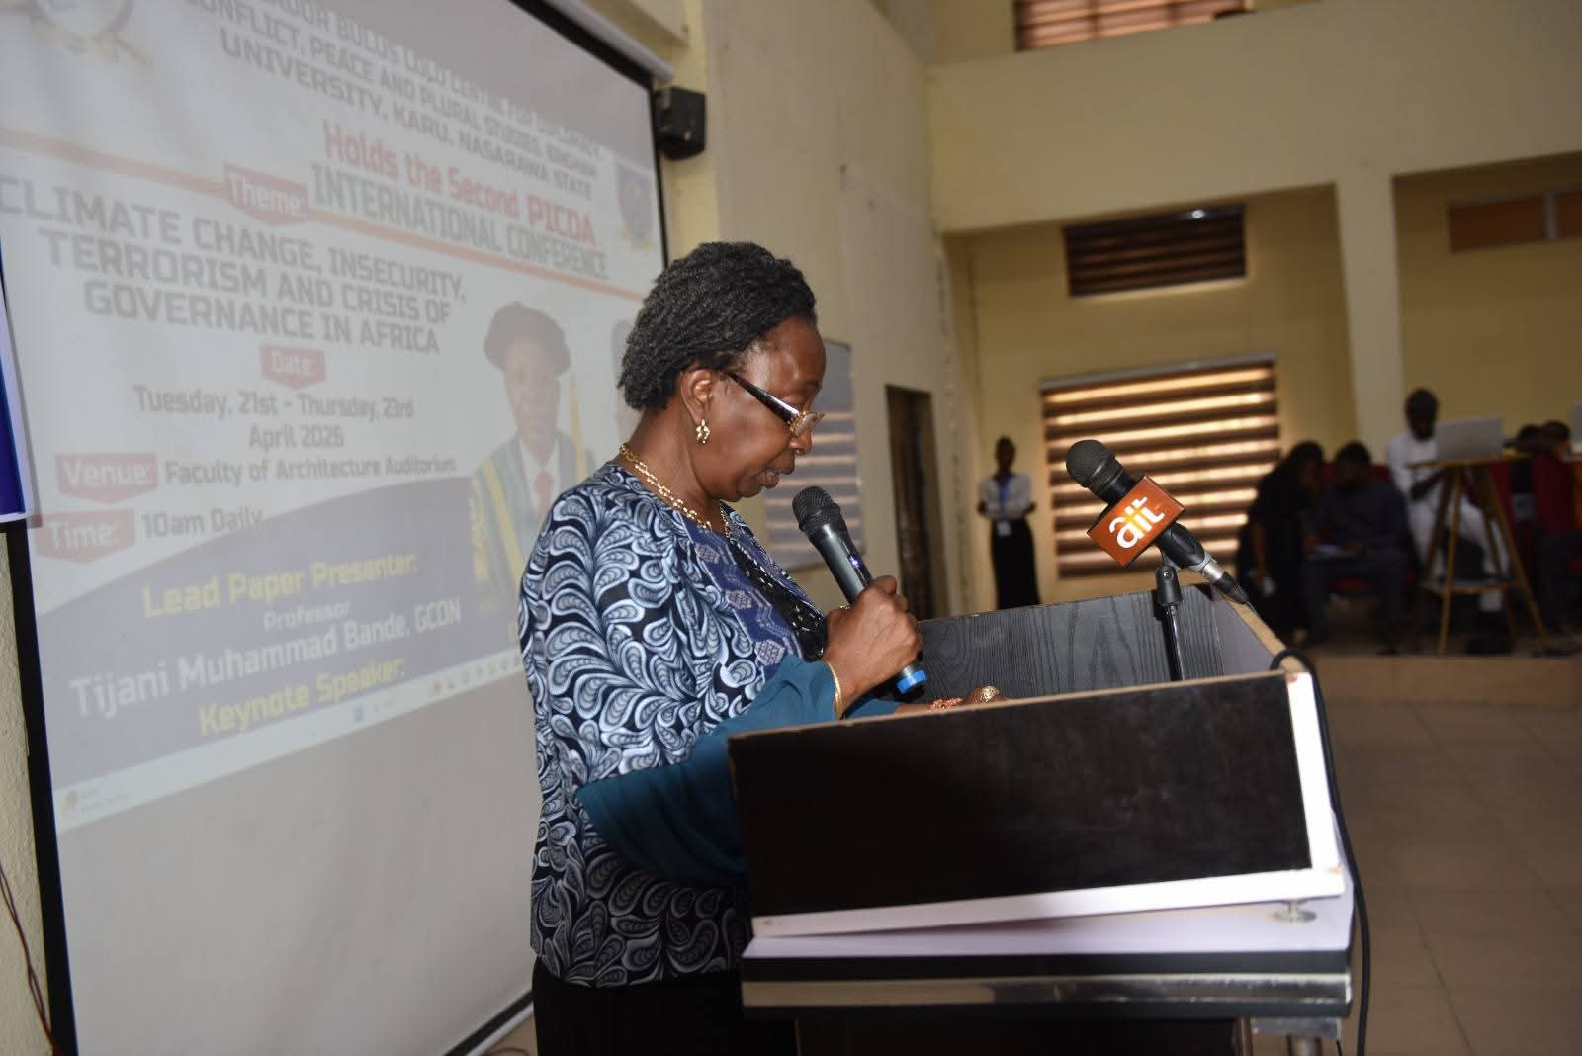
Madam Julie Sanda, Director-General, Plateau State Peace Building Agency delivering an Address on behalf of the Governor of Plateau State, Barr. Caleb Mutfwang

She explained how environmental stress turned farmer-herder adaptation into conflict, exploited by non-state actors amid weak institutions. She highlighted Plateau’s restructuring of its Environment Ministry, its 2026–2030 Climate Change Policy, Climate Assembly, and peacebuilding initiatives. She urged integrated responses, stronger trust, implementation, and coordination. She disclosed that the Governor had pledged support and seed funding for ABLC research to link academia and governance (See Annex IV).
GOODWILL MESSAGE BY THE REPRESENTATIVE OF THE SECRETARY TO THE GOVERNMENT OF THE FEDERATION (SGF), SENATOR (DR.) GEORGE AKUME, CON. The SGF was represented by Mr. Francis Ikyenge, Director (Office of the Secretary to the Government of the Federation). The Representative of the SGF said he was honoured to address the 2nd PICDA Conference and commended ABLC for creating a platform seeking pathways to stability, resilience, and sustainable development.

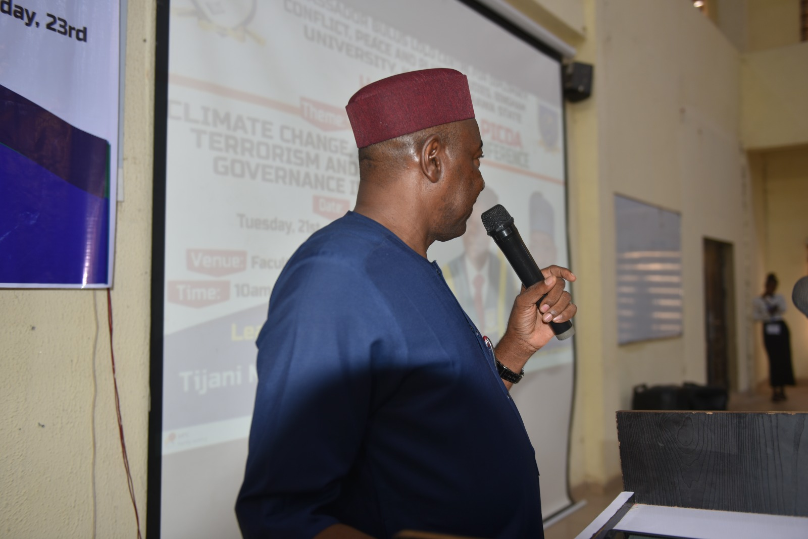
The SGF was represented by Mr. Francis Ikyenge, Director (Office of the Secretary to the Government of the Federation)

He noted that across Africa, climate stress, weak governance, and violent extremism had produced complex crises, with environmental degradation driving displacement, conflict, and fragility. He stated that President Tinubu’s administration prioritized a holistic approach, strengthening security coordination, addressing root causes like poverty and unemployment, and treating climate change as a national security concern through renewable energy, climate-smart agriculture, and afforestation. He highlighted governance reforms improving transparency and institutions, plus Nigeria’s active role in ECOWAS and the AU. He urged participants to translate insights into action and support leadership through constructive engagement for Africa’s peace and prosperity (See Annex V).
OTHER GOODWILL MESSAGES:
Goodwill messages were given by the representative of the Chairman of CORFEPS, Chief Akin Arikawe; President of ARCAN, Ambassador Joe Keshi; Ambassador of Cuba, Miriam Morales Palmero, Portuguese Ambassador Paulo Santos, Colombian Ambassador Marisel Romero Castillo, and Professor Hassan Saliu, President of the Nigerian Political Science Association(NPSA). The common thread in their messages emphasized the important roles and significance of the ABLC in focusing research and advocacy efforts towards Africa’s governance and security challenges, and the speakers were unanimous in their commendation of the leadership of Bingham University for the establishment of ABLC.
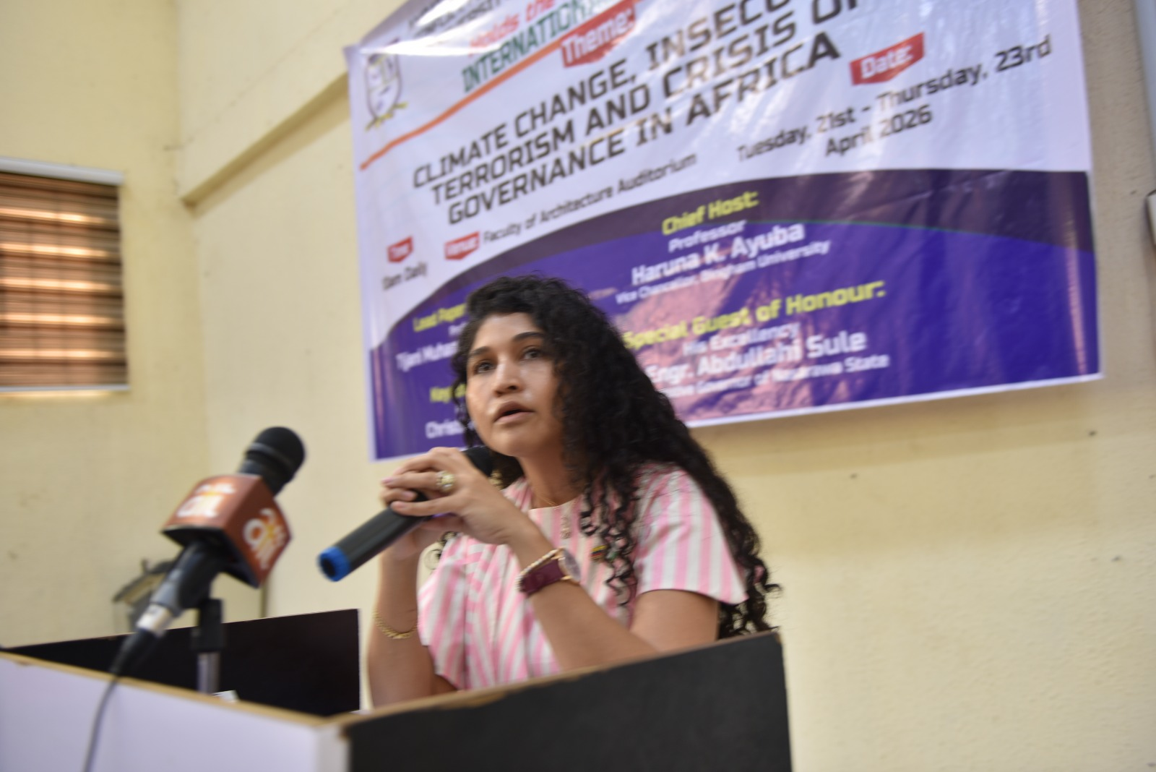
Colombian Ambassador Marisel Romero Castillo

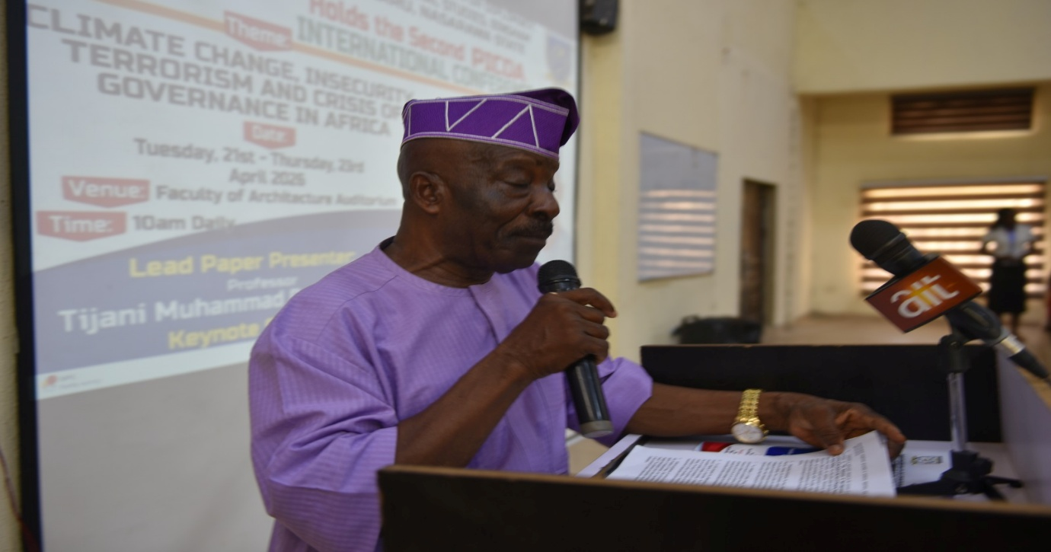
The representative of the Chairman of CORFEPS, Chief Akin Arikawe
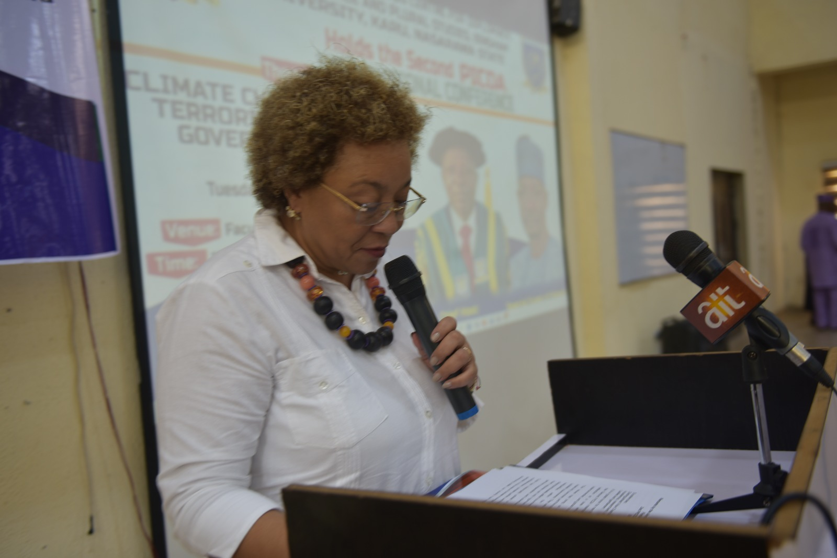
Ambassador of Cuba, Miriam Morales Palmero

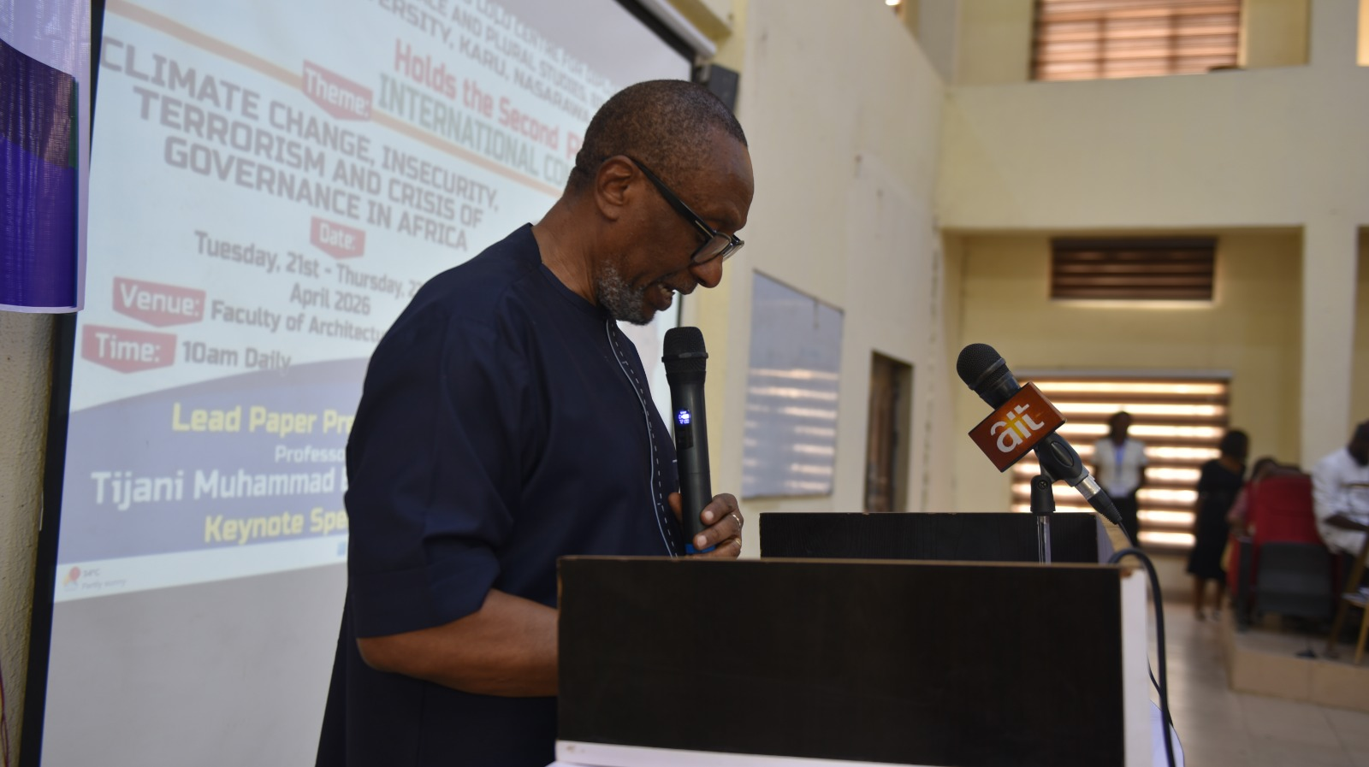
President of ARCAN, Ambassador Joe Keshi
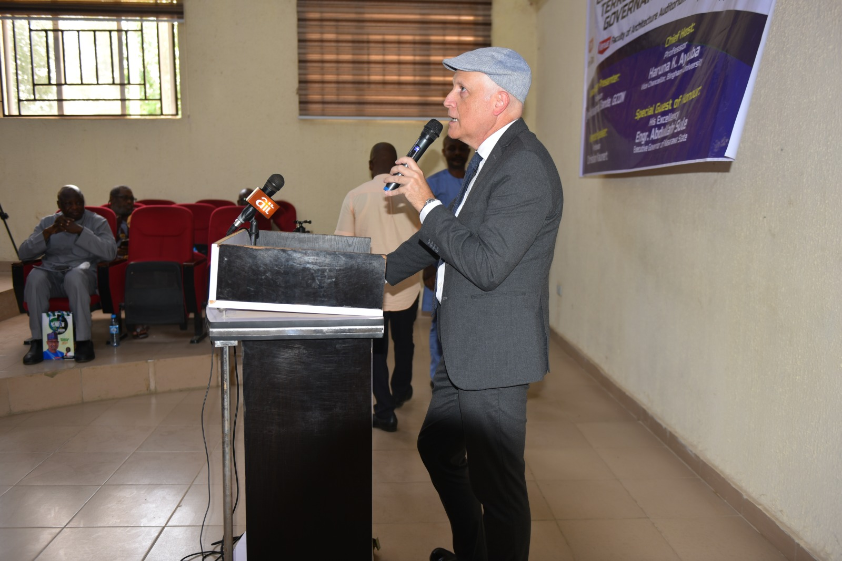
Portuguese Ambassador Paulo Santos

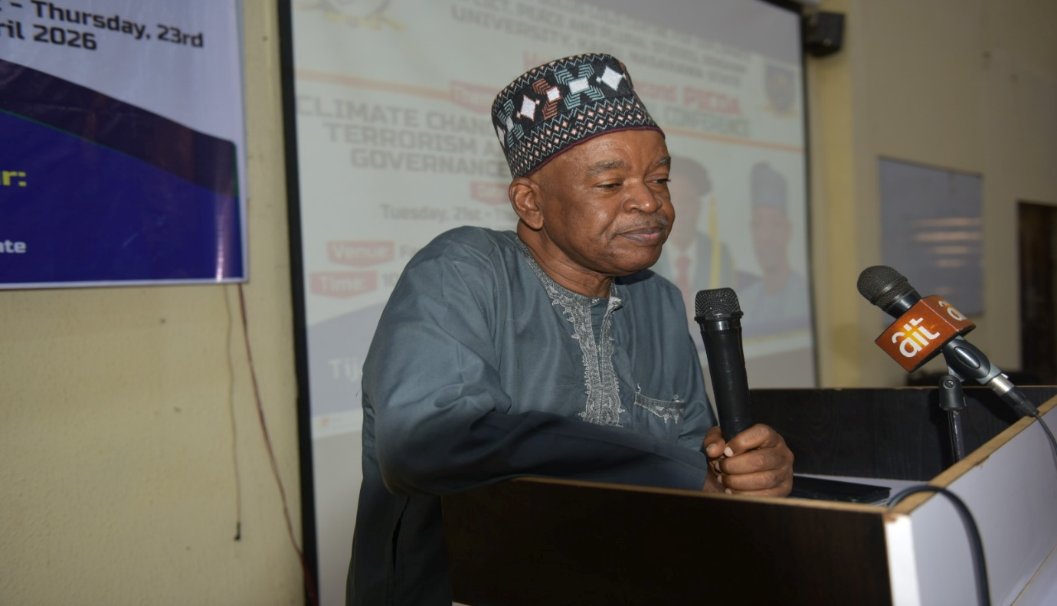
Professor Hassan Saliu, President of the Nigerian Political Science Association (NPSA)

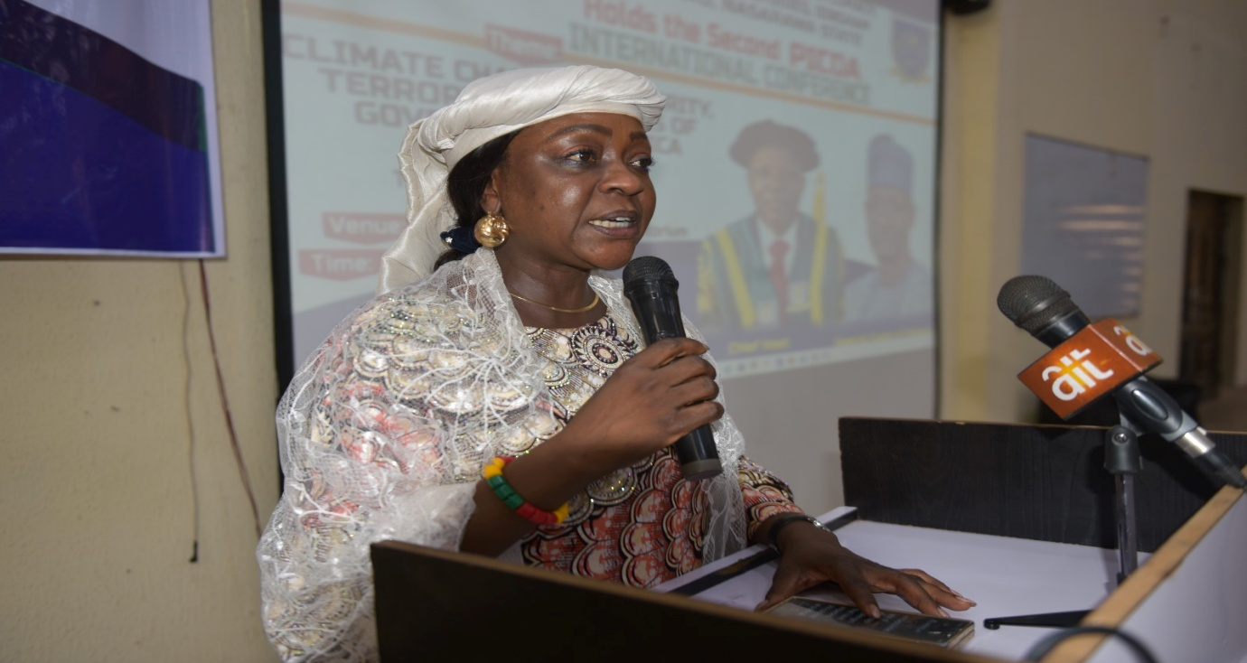
Barr. Dr. Deborah Usman

PROFESSOR TIJANI MUHAMMAD-BANDE’S LECTURE
Delivering the lead paper, former President of the United Nations General Assembly, Professor Tijani Muhammad Bande, GCON, warned that climate change is increasingly driving instability across Africa, worsening poverty and exposing the fragility of governance systems.
Presenting a paper titled: “The Climate insecurity, Governance Nexus in Africa: Evidence, Trends and Policy Implications”, Muhammad-Bande described Africa as one of the most climate-vulnerable regions despite contributing little to global emissions.
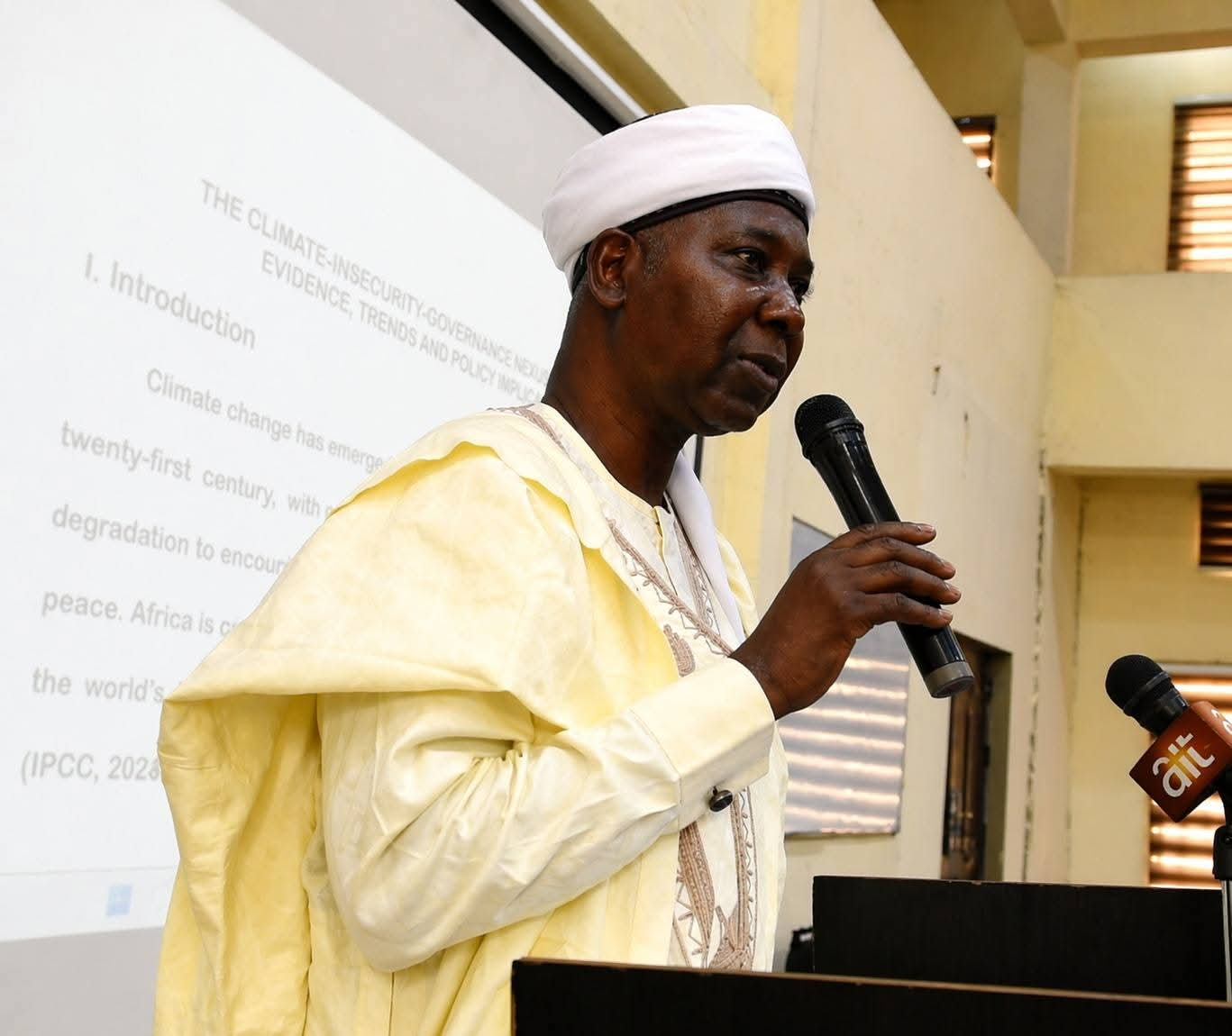
Professor Tijani Muhammad-Bande, GCON, delivering his paper.
He noted that rising temperatures, desertification and erratic rainfall are already disrupting livelihoods, particularly for communities dependent on agriculture and pastoralism. While climate change may not directly cause conflict, he said it intensifies unemployment, inequality, displacement and competition over land and water, creating conditions that can easily spark violence.
Professor Bande insisted that terrorism cannot be solved with local solutions alone, noting that small arms and light weapons are engineered elsewhere and sold cheaply to Africa. He argued that weak governance is often the deciding factor in whether climate stress escalates into insecurity. According to him, where governments fail to provide services or manage resources fairly, armed groups exploits grievances to recruit young people.
Continuing, he cited Boko Haram and ISWAP in the Lake Chad region, JNIM in Mali, and Burkina Faso, Al-Shabaab in Somalia and the insurgency in Mozambique as examples of extremist groups expanding in fragile environments marked by poverty and state neglect. He argued that the world is connected but deeply uneven, with some regions creating far more problems for others than they experience themselves.
Professor Bande emphasized the central nexus between climate change, governance, and security, urging Nigerians to address their problems collectively not as regional champions but as a united nation and as part of a region and a world.
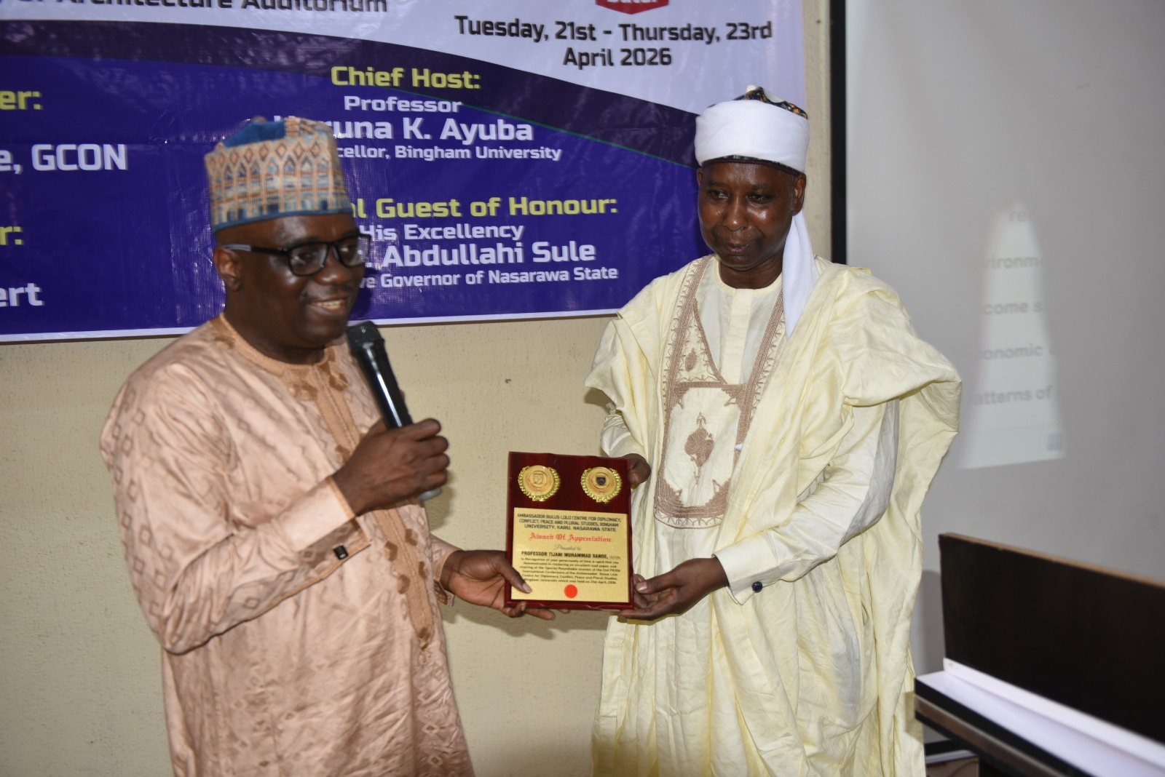
Presentation of plaque to Professor Muhammad-Bande by the Deputy Vice Chancellor, Professor Musa Dankyau

PHOTOGRAPH WITH SPECIAL GUESTS
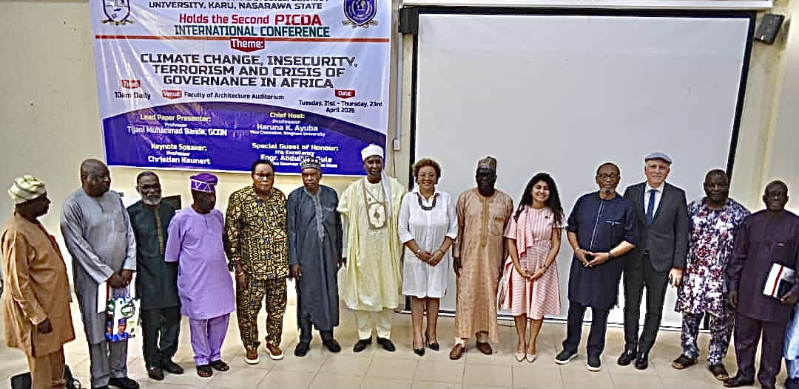
The Opening session of the Conference ended at 1.32pm and the coffee –Tea break took place immediately at designated venues. The special guests had their refreshments at the Senate Chambers while other participants and attendees had theirs at two serving points within the Faculty of Architecture Auditorium.

AFTERNOON SESSION: 2.15- 4.50pm
ROUNDTABLE ON THE PROSPECTS OF NON-ALIGNMENT POLICY AND POLITICS BY COUNTRIES OF THE SOUTH IN CONTEMPORARY TIMES
VENUE: Council Chambers, Bingham University.
DATE: 21st April, 2026.
Chairman – Prof. Tijani Muhammad-Bande, GCON, Former Nigerian Permanent Representative to the United Nations, and 74th President of UNGA
Lead Discussants/Panelists
- Prof. Emeka Okereke, National Defence College
- Prof. Sunday A. Ochoche, Fmr. DG, IPCR
- Prof. Istifanus Zabadi, Bingham University.
Moderator: Dr. Umar Abdullahi, IPCR
Rapporteurs: Dr. Olwatobi Johnson, Dr. Ropheka Bot
The Chairman opened the session by noting that the end of the cold war seems to have brought an end to the Non-Alignment Movement (NAM). One of the aftermaths of the cold war is that Western democracy gained traction especially in developing countries in the global south. However, the global challenges of the countries of the global south remained. As such, Non-alignment as a policy is still active particularly given the current geopolitical undercurrents in the global system.
Prof. Emeka Okereke noted that NAM in contemporary times is geared towards the development of the countries of the south. The relevance of Non-alignment to the global south is directly proportional to their survival. The Non Aligned Movement is about solidarity and finding shared problems such as insecurity and economic hardship ravaging developing countries.
Prof. Sunday Ochoche noted that NAM originated to cater for collective interest of the weaker states and newly independent countries trying to survive from the control of their colonial masters. They were mainly poor states that had to stand up against colonization and fought for the liberation of other colonized states. NAM, he argued, was instrumental in the liberation of so many countries of Africa from the clutches of colonial rule.
In recent times, climate change has a direct correlation with insecurity, terrorism, farmer-herders clash. Although, members of the roundtable agreed that there is no causal relationship between them and that could be regarded as a weak independent analysis of the problem of insecurity.
Prof. Istifanus Zabadi noted that NAM was formally launched in Belgrade, Yugoslavia. Not aligned with or against any ideological bloc – Western or Eastern. The current chair of the Non-Aligned Movement is Uganda. NAM was not just about neutrality. It is about giving a voice to weaker states and political sovereignty. NAM commits to shared values such as equality, independence, non-interference in domestic affairs, no military bases set up in member states by great powers.
NAM is focused on achieving economic freedom for its members in an attempt to create a New International Economic Order. NAM utilizes summit diplomacy, south-south cooperation especially through the Group of 77 (G77).
The Non-Aligned Movement has a major limitation as members are partially aligned to a power bloc. The prospects of NAM include; strengthening the United Nations (UN). The 2024 19th summit focused on deepening cooperation for shared values. NAM is also committed to achieving the 2030 Sustainable Development Goals (SDGs).
After a very robust question and answer session, the roundtable resolved that:
- NAM is still relevant in the contemporary world even though it needs rejuvenation.
- NAM could adopt the strategy of India which requires switching to Multi-Alignment and benefit from all the blocs rather standing apart. This is because the countries of the global south (developing countries) are better off solving their problems by simultaneously aligning with the United States (US) and its Western allies and with China and Russia.
- NAM is a sentimental idea that has been reframed in contemporary times as strategic autonomy. This is because NAM gives each member country the latitude to pursue its national interest and develop at its own pace in consonance with its foreign policy.
- NAM is a platform amongst other mechanisms for developing countries to negotiate and secure their collective interests. The G77 is pivotal in achieving this.
- Taken literally, abstinence from voting by countries on certain issues in the UN system is a form of Non-Alignment.
- There is the need to hold another high level meeting to deliberate on the foreign policy options for Nigeria similar to the 1986 Kuru meeting where Nigeria will take a stand on the direction of its foreign policy.

ROUNDTABLE ON MEDIA COVERAGE OF TERRORIST ACTIVITIES AND INSECURITY IN AFRICA.
DATE: 21 April 2026
VENUE: Senate Chambers
Chair: Prof. Desmond Okocha, Dean, Faculty of Communications and Media Studies
Lead Discussants/Panelists
1. Mr. Aliyu Mshelia, Directorate of News, NTA (Represented Mr. Ayo Adewuyi, Executive Director (News), NTA)
2. Ms. Henrietta Ibrahim, Director New Media, Federal Radio Corporation of Nigeria
3. Mr. Madu Onuorah, fmr Defence Correspondent, The Guardian Newspaper (Represented Mr. Martins Oloja, Fmr. MD, The Guardian Newspaper)
4. Mr. Victor Mayomi - Public Analyst
Moderator - Assoc. Prof. Gabriel Nyitse
Rapporteurs: Dr. Go’ar David Dogara, Dr. Ebunoluwa O. Popoola, & Mr. Solomon Chung Musa
The Chairman opened the session by noting that the African continent faces armed conflicts and terrorism, and these pose challenges to the media who are major stakeholders with a major role to play in fostering/restoring peace. The media is required to balance patriotism with professionalism; the right to know with national security.
Mr. Madu Onuorah noted that insecurity is rooted in failure of governance; that although journalists have a duty to report the truth, they are constrained in how much they can report. Challenges identified include pressure from political leaders and ownership and control of the media. He however encouraged journalists to report the truth within the available limits.
Ms. Henrietta Ibrahim stressed the need for professional discretion in reportage to avoid inflaming tensions. The language used and figures mentioned are important. She highlighted the challenge of social media, which now sees non-professionals breaking news. The journalist therefore needs to follow the rules of engagement, verify their facts, and do their work professionally.
Mr. Victor Mayomi highlighted the three key roles of the media: to inform, to enlighten, and to be the watchdog of society. While inadequate reportage fosters ignorance, too much could amplify fear and terrorist propaganda; thus, proper framing of the narrative is crucial. He identified fragmentation and politicization of insecurity as major challenges. Social media, which provides terrorists with visibility, is another challenge.
Mr. Aliyu Mshelia spoke on the need for national security and conflict-sensitive reporting that prioritizes national interest. Major limitations in reportage by the state-owned media include the necessity of verifying information before reporting. He further noted that much of the terrain is inaccessible to journalists, thereby fostering their reliance on official bulletins and hand-outs. He questioned the failure to embed journalists within the troops and recommended adoption of the practice within Nigeria.
The moderator observed that the Nigerian media lacks adventurism and is over-reliant on government patronage.
During the question and answer session, questions and comments centred on prioritizing the public interest over the interests of those in government; investigative journalism and shortcomings in media reportage, failure to harness the collective power of the media and professional bodies/unions in protecting the right of the press, avoidance of sensationalizing insecurity and balanced reporting that acknowledges government programs. A lead discussant responded that journalists are required to adhere to the protocols on reportage in war situations. He recommended cooperation between security forces and the media founded on the national interest and the building of a reformed and strengthened police force.
The Chairman and lead discussants, responding, spoke on the peculiar challenges of journalists in Nigeria, which makes their task herculean. These include lack of life insurance, poor remuneration and conditions of service, pressure from government, civil and criminal prosecution, the economy of journalism, overreliance on government patronage, and undue influence of persons in power on professional bodies/media unions. They drew a distinction between the shadow media/citizen journalism and the organized/professional media and the need for media literacy to enable citizens discern credible sources. The war economy and lack of political will were identified as factors behind the persistence of insecurity in Nigeria
Concluding, journalists were encouraged to be courageous, professional, uphold ethics, while acting in the national interest; attention should be paid to journalists' welfare. The support of citizens for the media is crucial.
END OF DAY ONE CONFERENCE ACTIVITIES: The roundtables ended at 4. 50 pm, and participants were served lunch in take-away packs.
DAY TWO- WEDNESDAY 22ND APRIL, 2026
Presentations at the panels on the second day of the conference commenced at 10.30am commenced after the Coffee- Tea Break.
PANEL ONE
THEME: Governance, Democracy, Pluralism and Security Issues in Africa
Venue: Council Chambers
Chair: Prof. I. S. Zabadi, Department of Political Science, Bingham University, Karu
Discussant: Assoc. Prof. Mercy Anshase, Department of Mass Communication, Bingham University, Karu
RAPPORTEUR: Mr. Gana Makun, Department of Library and Information Science, Bingham University, Karu

Opening Remarks: The panel session commenced at 11am with an introduction of the discussant, participant, students, and other dignitaries in attendance by the chairman. Professor Tijani Mohammed Bande was in attendance. The chairman emphasized the need for participants to be open-minded and feel free to learn from comments and perspectives of others. The Panel had eleven papers listed for presentation but only two presenters were in attendance to present while the other presenters opted for the online presentations.
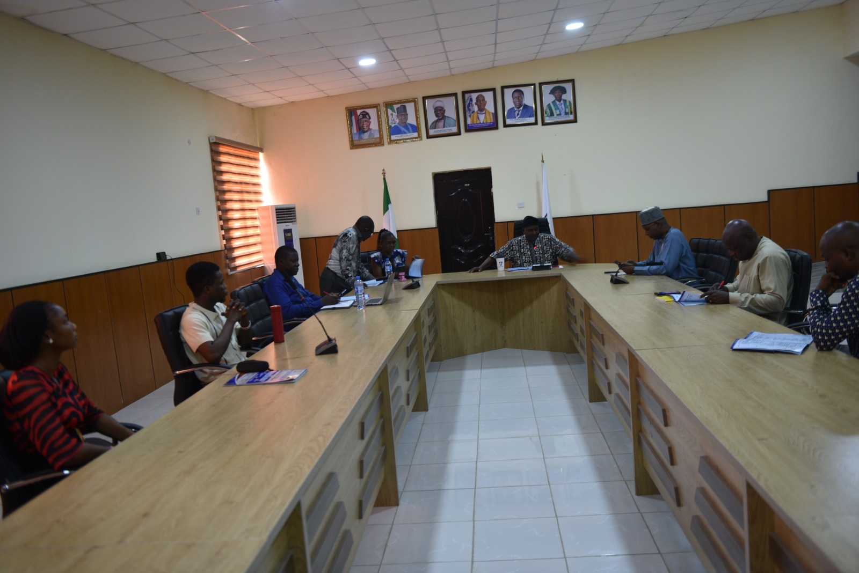
Dr. Olushola John Magbadelo, making his presentation in Panel One which was chaired by Professor Istifanus Zabadi, with Professor Tijani Muhammed-Bande in attendance.

Paper 1: MANAGING DIVERSITY THROUGH EQUITY AND INCLUSIVE LEADERSHIP: A RECURRING GOVERNANCE CHALLENGE IN NIGERIA

Author: JOHN OLUSHOLA MAGBADELO

The author started by asking a basic question about how we manage diversity in Nigeria.
Managing diversity through equity and inclusive leadership remains a persistent governance challenge in Nigeria due to the country’s complex socio-cultural composition. Nigeria is characterized by significant ethnic, religious, and regional diversity, which necessitates deliberate strategies to ensure fair representation, equitable resource distribution, and social cohesion. Equity, in this context, extends beyond mere equality to emphasize fairness in addressing historical imbalances and systemic marginalization among different groups. Mechanisms such as federal character principles, quota systems, and zoning arrangements have been introduced to promote inclusiveness; however, their implementation has often been inconsistent and, at times, influenced by political considerations.
Inclusive leadership complements these structural measures by fostering participatory decision-making, representation, and a sense of belonging among diverse populations. It requires leaders to engage with and integrate multiple perspectives in governance processes. Nevertheless, challenges such as ethnic favoritism, political patronage, weak institutional frameworks, and limited accountability have constrained the effectiveness of inclusive leadership in practice.
The recurring nature of this governance challenge reflects the gap between policy intentions and practical outcomes. While frameworks for managing diversity exist, persistent inequalities and perceptions of exclusion continue to undermine national unity and effective governance. Therefore, achieving sustainable diversity management in Nigeria requires strengthening institutional mechanisms, ensuring transparent and equitable policy implementation, and promoting leadership approaches that genuinely reflect inclusiveness and fairness across all segments of society.
In conclusion, he observed that Nigeria’s federal character mechanism of representation should be anchored on merit-based principles.
Comments
The panel noted that Human beings differ even when they speak the same language. All have to be harnessed that things may work very well. It was also noted that Nigeria could have emerged through natural state formation processes without the intervention of the colonial administration. History has been deemphasized in Nigeria, and the subject needed to be taken seriously because it would help the younger generation to appreciate the country’s developmental efforts across different historical epochs. The policy of affirmative action could also help address the issues of leadership and diversity management in pluralistic countries including Nigeria.
Paper 2- : YOUTH UNEMPLOYMENT AND ITS LINK TO TERRORISM AND INSECURITY
Authors: GO’AR DAVID DOGARA, OYINLOYE D.O., DARE ABEL LAMIDI, MAKUN GANA, & DANGWARAN Y. TABAWA
Youth unemployment has emerged as a critical socio-economic and security concern, particularly in developing contexts where large youth populations face limited access to gainful employment. The phenomenon reflects not only economic stagnation but also structural challenges such as inadequate education systems, skills mismatches, weak industrial capacity, and poor policy implementation. As unemployment persists, many young people experience frustration, social exclusion, and diminished prospects for upward mobility.
The link between youth unemployment and terrorism and insecurity is often explained through strain theory and opportunity cost theory. When young individuals perceive a gap between their expectations and actual opportunities, feelings of marginalization and resentment may intensify. These conditions can create a fertile ground for recruitment into extremist groups, criminal networks, and other forms of violent activity, especially in environments where governance is weak and state presence is limited. Terrorist organizations and insurgent groups frequently exploit such vulnerabilities by offering financial incentives, a sense of belonging, or ideological justification.
However, while youth unemployment can contribute to insecurity, it is not a sole or deterministic cause of terrorism. Factors such as political instability, ideological indoctrination, corruption, inequality, and weak security institutions also play significant roles. The relationship is therefore complex and multidimensional, with unemployment acting as a reinforcing condition rather than a direct trigger.
Addressing this challenge requires integrated policy responses that combine economic, social, and security strategies. These include job creation initiatives, vocational training and skills development, educational reforms aligned with labor market demands, and inclusive governance that engages youth in decision-making processes. Strengthening institutional capacity and promoting social inclusion are also essential to reducing vulnerability to radicalization and enhancing national security.
Comments:
The discussant noted that the topic has been widely researched on and asked the presenter what was new that the paper has discovered? The chairman added that every society must renew it self for the future, stating that the informal sector employs more youths than the formal sector of the economy. Some of the panelists noted that the researcher needed to get current data to back up some of the claims in the work
Closing Remarks: The panel session concluded with a call for the presenters to go back and work on the areas pointed out and resubmit their papers. The chair expressed his appreciation to all presenters and attendees for their valuable contributions to the discussion. The panel session ended at 1:40 pm.
PANELS TWO & FOUR
THEME: Climate Change Governance, Resource Pressures and Food Security Challenges
Venue: Pol. LH1
Chair: Amb. Bulus Lolo. ; Co-Chair Professor Gani Yoroms
Discussant: Assoc. Prof. Joseph Shawai.
Rapporteurs: Barr. Dr. Go’ar Dogara, Dr. Esther Aina, & Cordelia F. Clayton
Opening Remarks: The panel session commenced at 11am with an introduction of the discussant, participants, students, and other dignitaries in attendance by the chairman. The chairman emphasized the need for participants to highlight only the key points of their papers because of the paucity of time. The Panel had fourteen papers listed for presentation but only nine presenters were in attendance to present. Panel two was fused with Panel four.
Paper 1: IMPLEMENTATION APPROACH OF FADAMA III PROJECT AND SMALL SCALE FARMER PRODUCTION OUTPUT IN JOS SOUTH, PLATEAU STATE
Authors: BOT, POLYCARP MOSES & GRACE HEZEKIAH ISA
The Presenter recommended that:
Fadama III policy makers should involve the participants in the identification, prioritization of needs, design and implementation, monitoring and evaluation of projects in their communities.
Provides continuous capacity-building for small-scale farmers in modern farming techniques, input use and farm management to reduce reliance on traditional methods.
Comments:
The Panel commended the focus of the paper but raised questions about the methodology utilized in the research. The panel recommended a change of the methodology to a more empirical one, noting also that more statistical analysis of the project under study should be carried out.
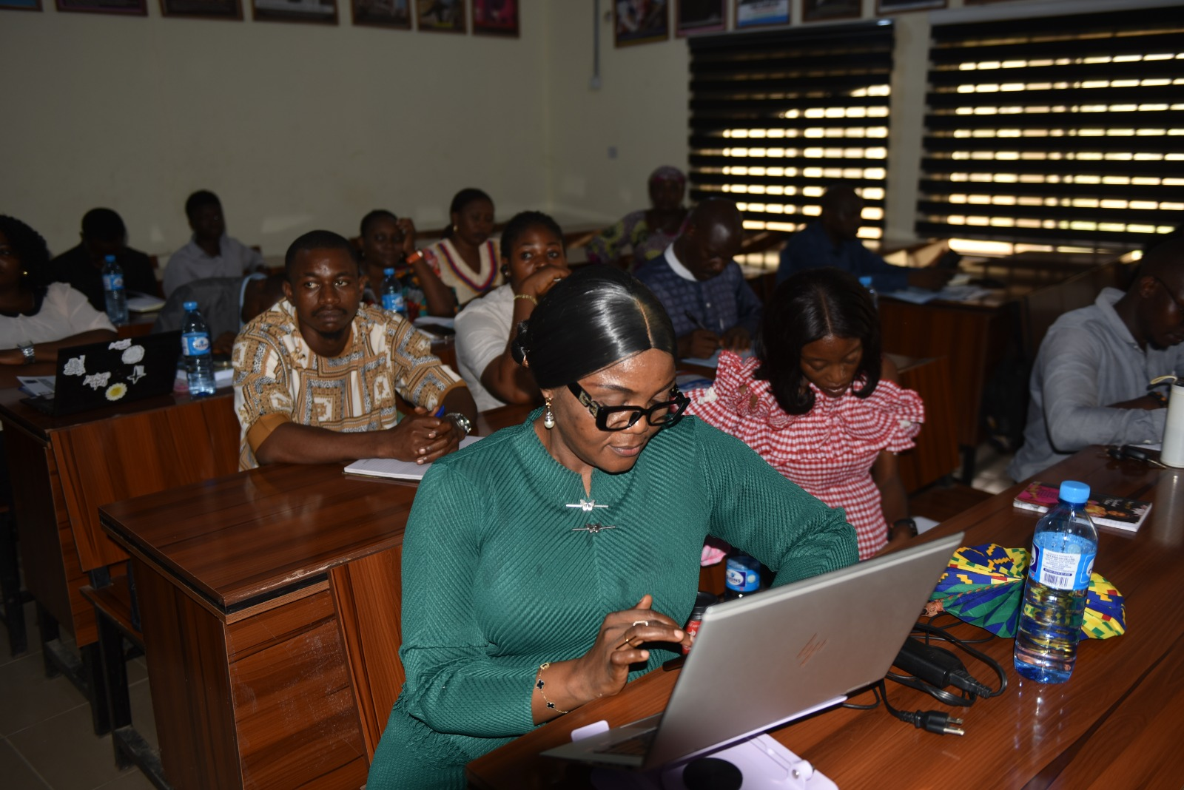
Dr. Hope Imuetinyan Ighuodala-Cole making her presentation in Panel Two, which was chaired by Ambassador Bulus Lolo.
Paper 2: CLIMATE CHANGE AND GENDERED PERCEPTION OF OCCUPATIONAL SAFETY AND SECURITY AMONG AIR TRAFFIC CONTROLLERS IN AFRICA
Author: HOPE IMUETINYAN IGHUODALA-COLE
Comments:
The panel made remarks concerning the equipment, ANC (aviate, navigate and communication) and the need for the presenter to completely restructure the paper.
Paper 3: GOVERNACE, RESOURCE PRESSURES AND CONFLICT RESOLUTION IN AFRICA
Authors: FELIX O. ODOFIN & SAMUEL ODOMA
Comments:
The panel raised issues about the broad focus of the paper without specific reference to any African country as a case study. African countries are diverse and theorizing on a general basis stands the risk of over-generalization, adding that governance itself must be context-specific. The presenter was advised to re-work the paper on the strength of the observations made by the panel.
Paper 4: AN APPRAISAL OF PROSPECTS AND CHALLENGES OF SUBSIDARY LEGISLATION ON CLIMATE CHANGE GOVERNANCE IN NIGERIA
Authors: EBUNOLUWA ODUNAYO POPOOLA, WADZI V. ABOKI; GLORIA
The presenter emphasized that subsidiary legislation was indispensable for Nigeria’s climate governance, which offers the technical specificity required for global compliance.
Comments:
The panel commended the authors for a well- researched paper.
Paper 5: CLIMATE WASHING AND SUSTAINABLE OIL AND GAS INVESTMENT PERFORMANCE IN NIGERIA
Authors: GOFWAN HASSAN, AKINYELURE T. FIDELIA; LEONARD AUDU
Comments:
The panel emphasized the need for the paper to be restructured and key concepts in the paper to be clarified for easy comprehension.
Paper 6: FOOD INSECURITY AND MALNUTRITION: UNDERSTANDING THE NEXUS
Authors: ANYANWU G. O; AKANDE S. A
The presenter stated that a cost-effective multi-sectorial approach is necessary to combat food insecurity and improve nutrition, including subsidizing healthy foods, taxing calorie-dense refined beverages, incentivizing agricultural production, advocating nutrition education, and initiating healthy lunch programs at workplace and in the Academia.
Comments:
The paper was commended for its focus but the authors needed to provide the context in order to make the contents and analysis empirical.
Paper 7: AN ECOLINGUISTICS ANALYSIS OF ATTITUDE AND GRADATION IN THE REPORTAGE OF CLIMATE CHANGE IN SELECTED NIGERIAN NEWSPAPERS
Authors: PRISCA GODSPOWER OCHULOR; NAPHTALI KAKAYE ZIRA
The two selected Nigerian newspapers exemplified reporter’s narratives on climate change and the writers’ attitudes and gradations. It is observed that instead of graduating to elevate fear and recommend a solution to the reader, it creates uncertainty and further fear, thereby increasing pain in readers’ lives
Comments:
The panel expressed satisfaction with the paper on grounds of its analytical rigour and empirically verifiable data.
Paper 8: TERRORISM AND ITS EFFECT ON NATIONAL DEVELOPMENT
Authors: GO’AR DAVID DOGARA, WATZI VIVIAN ABOKI, GLORIA NAKOP YOHANNA, FAITH EPAHPHRAS ANZOLO, OTHNIEL PHILEMON RETSHIK
Method adopted by the paper was a qualitative research design
Findings of the paper revealed terrorism significantly disrupts economic productivity, deters, investment, displaces populations and weakens state institutions, creating a compounding cycle of underdevelopment that disproportionately affects already vulnerable nations.
Recommendation:
The article recommends that national governments adopt integrated security development policy frameworks that embed counter-terrorism operations within explicit developmental objectives. The post-conflict reconstruction and institutional rebuilding must be elevated to core elements of national development strategy, receiving comparable policy priority to conflict prevention. The paper recommends the strengthening of regional cooperation mechanisms, investment in poverty alleviation initiatives to mitigate economic conditions that breed extremism, adding that governments should prioritize post- conflict reconstruction as a core component of national development strategy.
Comments:
1. The researchers were advised to give statistics in the study as it is lacking in the work.
2. The statement of the problem should be shortened as it looks too lengthy
Paper 9: CLIMATE CHANGE & ENVIRONMENTAL SUSTAINABILITY: POLICY AND PLANNING STRAREGIES FOR SUSTAINABLE DEVELOPMENT IN NIGERIA.
Authors: OGWUCHE DAVID, EJIMA AJAYE OCHIDI &ADEJOR, A. GABRIEL
For effective and actionable policy implementation and planning the Federal Ministry of Environment through its agencies such as the presidential initiative on climate change should aggressively embark on climate mitigation strategies such as enforcing stricter emission controls and increased investment in renewable energy infrastructure.
Comments:
The methodology was recommended to be changed.
Closing Remarks: The panel session concluded with a call on the presenters to go back and work on the areas pointed out and resubmit their papers before the end of June, 2026. The chairman expressed his appreciation to all presenters and attendees for their valuable contributions to the discussion. The panel session ended at 2:40pm.

PANEL FIVE
Venue: SOC LH2
THEME: Good Governance in Africa: Challenges, Prospects and Benefits
Chair: Professor John A. I
Discussant: Dr. Sebastian Abu
Rapporteur: Dangwaran, Tabawa
The panel v presentation commenced at 10am. The chairman of the panel welcomed participants to the session. He counseled that the presenters should go straight to the main points of their papers, and highlight the significant strengths of their findings and recommendations.
Paper 1: GOOD GOVERNANCE AND SECRECY IN NIGERIAN DEMOCRATIC DEVELOPMENT
Author: SABO ROBERT
The presenter described secrecy as a global tradition being practiced by governments including even the democratic ones. Secrecy, he argues, affects democracy, noting that if the state must survive, Secrecy of vital security matters must be preserved. He affirmed that Secrecy plays a significant role in governance, highlighting the reasons for secrecy to include survival of the state and public safety, which in the long run would lead to good governance. State should be left alone in order to allow it to survive. The presenter stated that restoration of order in any society could be ensured through secrecy in governance.
Comments:
The panel observed that the word “Secrecy” was not operationally defined, and that its usage in the paper equated secrecy with good governance, which was a wrong rendition. There was every reason to believe that the author meant classified information which had different categories which the presenter did not include in his analysis. The presentation did not state or discuss clearly whether references to secrecy had to do mainly with the public sector or private sector, governmental or non-governmental political institutions. Finally, it was observed that the paper did not include recommendations. Responding, the presenter thanked the panel for all the observations and assured that necessary corrections would be made in consonance with the observations.
Paper 2: TOWARDS INSTITUTIONAL EFFECTIVENESS: LEVERAGING OF PUBLIC SECTOR DIGITALIZATION TO RETHINK JOB EVALUATION, PRODUCTIVITY MEASUREMENT AND COMPENSATION.
Author: UCHENNA NWANKWO
The presenter looked at the global perception of job evaluation and narrow it to Nigeria, noting that digitalization framework had gained prominence in diverse aspects of public administration in other countries of the world. He spoke briefly about the contents of literature review, and his adoption of quantitative analysis as the paper’s research methodology. His major argument is that Personnel pay should be commensurate with the job done, citing the example of a professor in the academia who lectures more than two courses, supervise both undergraduate and postgraduate students but receives the same salary with other professors with lesser workload. With advancement in ICT and the deployment of A.I, it is now possible to utilize digitalization in productivity measurement in Nigeria. He disclosed that the National Salaries and Wages Commission, Abuja recently sent some of its staff for training in Kenya on digitalization, job evaluation and productivity measurement in order for them to come and implement a fairer and more just compensation schemes in Nigeria. In conclusion, recommended the implementation of the UDOJI DECLARATION which he stated had never been implemented.
He also recommended that the government should establish a national job evaluation and national compensation board.
Comments:
The panel commended the paper but suggested the recasting of its title which appears too long. Since the National Salaries and Wages Commission (NSWC) was aware of the said Udoji Declaration, the panel enquired if the Commission was making any effort to actualize it. The panel enquired if the theory of digitalization of productivity measurement and job evaluation would be matched by actual practice in the Nigerian context. Responding, the author assured of the readiness of the NSWC to take steps to actualize Udoji Declaration, and ensure that digitalization of the Productivity measurement and job evaluation results in improved, fairer and just compensation for workers generally.
Paper 3: THE ROLE OF GOOD GOVERNANCE IN EFFECTIVE CONFLICT RESOLUTION: STRATEGIES FOR SUSTAINABLE PEACE
Authors: JOSEPH SIMON EFENJI, LAMIDI ABEL DARE, & OYINLOYE OLUWABUNMI
For good governance, conflict resolution should be done in a manner that does not create new conflict. Conflict prevention is superior to conflict resolution. Preventing conflict rather than managing it, requires social justice, good governance, and independence of the judiciary. The presenter recommended community engagement, good governance and conflict resolution, adding that structural reforms, building of strong institutions, would help greatly in the restoration of peace among others.
Comments:
The panel enquired why good governance was not clearly defined in the paper. The paper was silent on the place and role of the citizenry in good governance. The title of the paper was could be changed to: GOOD GOVERNANCE AND EFFECTIVE CONFLICT RESOLUTION: STRATEGY FOR ATTAINIG SUSTAINBLE PEACE. Responding, the presenter affirmed that the role of the citizenry in good governance was well-captured in the paper. He stated that the strategy for sustainable peace was also well-discussed in the paper.
Paper 4: UTILIZING ADVOCACY JOURNALISM TO PROMOTE RURAL DEVELOPMENT IN NIGERIA
Author: BEN ITA ODEBA
The presenter illustrated his paper with a story, stating the various dimensions of advocacy journalism which he noted were not new in Nigeria. Advocacy journalism can influence good governance. Media should act as the agency of marginalized people.
Comments:
The possibility of the misuse or abuse of advocacy journalism by mischievous people who could misinform journalists to propagate false information was pointed out. Advocacy journalism could be ideologically biased because the media could just be rigidly hooked on influencing the people in a predetermined way for interests unrelated to the overall well-being of the larger society. Responding, the presenter agreed that advocacy journalism could be abused, noting however that it could also be utilized positively to promote good governance and agitate for the protection of the socioeconomic and political rights of the people.
Paper 5: GOVERNANCE AND CONFLICT RESOLUTION IN THE 21ST CENTURY NIGERIA
Author: SAMUEL ODOMA
The paper is not an empirical paper but a theoretical one which is anchored on functional theory in sociology. There are various perspectives on conflict, but in the case of Nigeria, conflicts had often emerged from sources bordering on religious differences, tribal or ethnic identities, geographical or territorial competition for resources, etc. The poor management of crises resulting from these differences by the successive Nigerian governments has continued to create foundations for bigger conflicts among adherents of different religions, ethnicities and diverse communities in the country. Governments at both federal and state levels have been known to be favouring one religion over another while also promoting the interests of one ethnicity over others. This situation would not portray the governments as neutral arbiters that could resolve the any conflict at State and Federal levels. The presenter recommended that governments should be guided by the provisions of the country’s Constitution.
Comments: The paper needs to situate to situate its expectation of government as a constitutional institution empowered to resolve social and political conflicts within the context of good governance. No Constitution can implement itself; a government that is guided by the provisions of the Constitution, is one that would promote good governance. The paper has no abstract and does not have any section on recommendations, contrary to the verbal impression given by the presenter.
Paper 6: GOVERNACE FAILURE AND THE COLLAPE OF HUMAN SECURITY UNDER THE TINUBU ADMINISTRATION IN NIGERIA (2023-2025)
Author: VICTOR OTTAH
The presenter highlighted the challenges being faced by Nigerians under the Tinubu Administration as an indication of governance failure. He identified absence of checks and balances, poor service delivery, wrong prioritization of legacy projects above human security projects and programmes, among others, as visible policy flaws of the administration. .
Comments:
The paper based its assessment on a very short period of just two years which would appear an unfair and hasty assessment of an administration that inherited catalogues of economic problems. The paper did not review the conditions of the country when the administration came into the saddle of leadership, and therefore its assessment would appear as a biased one lacking objectivity. The absence of relevant data to support the position of the paper is a clear indication that the paper is not an empirical analysis of the administration.
Closing Remarks: The chairman thanked the participants and implored them to ensure that they resubmit their corrected papers on time, so that it could be included in the published Proceedings of the Conference in June, 2026.

PANEL SIX
Venue: Department of Political Science Large Hall 1.
Chair: Prof. Michael Akpan
Discussant: Dr. Hope Imuetinyan Ighuodala-Cole
Rapporteurs: Dr. Terhile Agaku & Dr. Nelson Christopher
Paper 1: THE PSYCHO-SOCIOLOGICAL BURDEN OF THE NEW TAX REFORMS LAWS IN NIGERIA.
Authors: OCHENEHI DOMINIC SUNDAY & OMEIHU JULIUS BEIDA
The study revealed that the complex tax system characterized by high rates, multiple taxation and substantial compliance costs affects small scale businesses as it hinders profitability. Growth and competiveness. The study therefore recommended that government through NRS should embark on massive awareness on the need to pay taxes, there should be inter-agency collaboration to support tax collection, tax leakage should be discouraged and tax payers should be educated on their rights and responsibilities regarding taxation.
Comments
The authors should provide the broad objective of the study while the research methodology should equally be clearly stated.
Paper 2: DIASPORA POPULATION AS A STRATEGIC FOREIGN POLICY ASSETS: A MIXED METHOD ANALYSIS OF NIGERIA ENGAGEMENT FRAMEWORK.

Author: SABASTINE ABU
The study revealed that there is institutionalization of diaspora engagement through the Nigerians in Diaspora Commission and the 4Ds of foreign policy framework of democracy, demography, development and diaspora that marks a fundamental change in Nigeria’s statecraft. Diaspora population also exposes a strategic gap which exposes the weakness of organization and the international organizations known for their competitiveness. The study thus recommend operationalizing the proposed diaspora trust fund, expanding technological platforms for engagement and institutionalizing diaspora consultation in foreign policy formation.
Comments
The abstract should reflect the broad objective of the study while the discussion of findings should align with the research objectives. The author should equally use likert scale to determine the degree of diaspora engagement and the rationale for the study should be clearly stated in the background of the study.
Closing Remarks: The Chairman expressed satisfaction with the efforts of the participants, and advised them to quickly make necessary corrections and resubmit their papers, so that it can be included in the Proceedings of the conference which would come out in June, 2026.
VIRTUAL PANEL
Venue: Senate Chambers
Chairman: Dr. Oluwatobi Johnson
Discussant: Dr. Ropheka Emerson Bot
Rapporteur: Mr. Michael Agbo John

The presenters had 10 minutes for their presentations, 19 presenters were captured but one had network glitch. Hence, 18 papers were fully presented.
The chairman had made it known that the comments from the reviewers will be made available to each presenter to enrich their work.
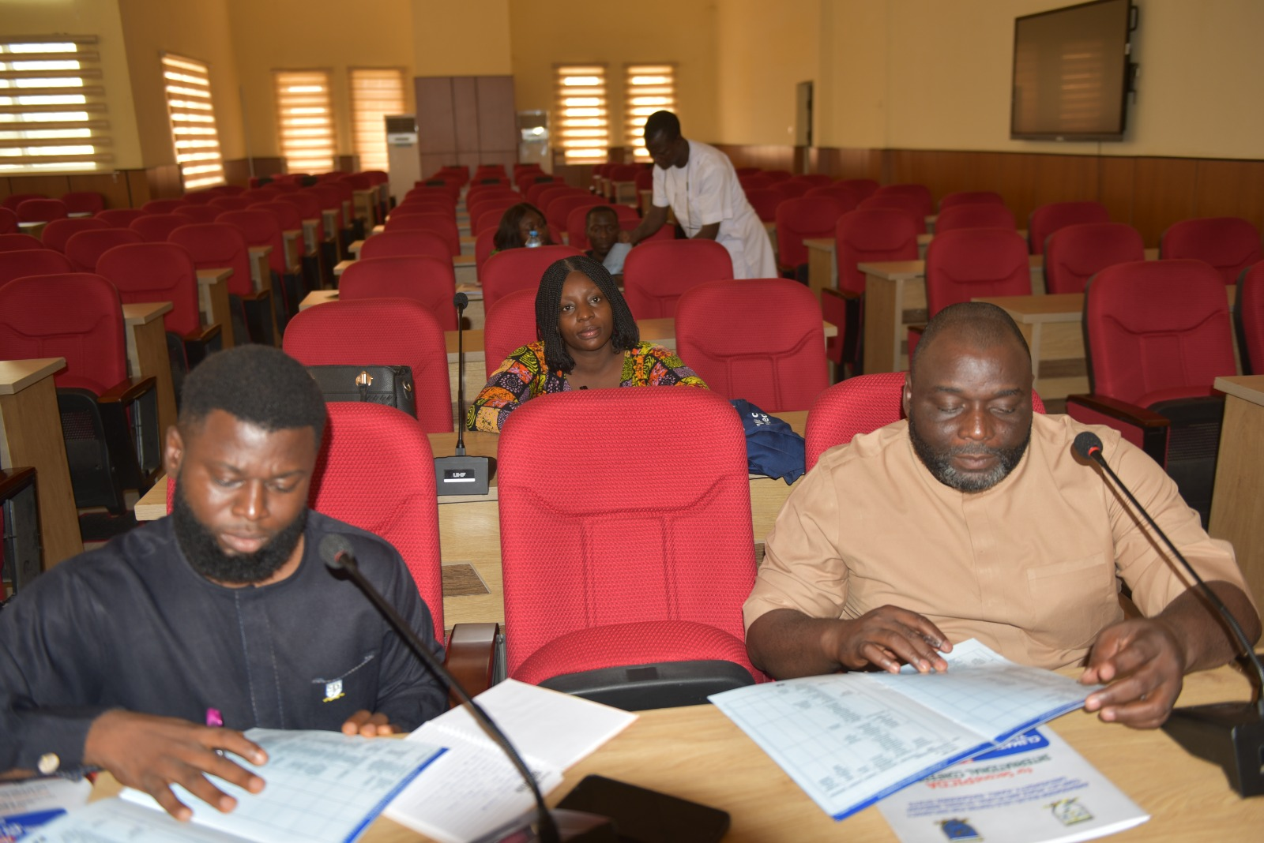
Virtual Panel Presentation coordinated by Dr. Oluwatobi Johnson; Dr. Michael John Agbo and Dr. Ropheka Bot

Paper 1: GOVERNANCE THEORY AND ITS IMPLICATIONS FOR NIGERIA AND RIVERS STATE.
Author: VICTOR OKERE
Using secondary data, the paper established that Nigeria has faced governance challenges between 2023 and 2025 using the Rivers State Governor Fubara and the State House of Assembly fracas. Owing to the fact that corruption, lack of transparency, unaccountability of political office holders, non-participation of citizens in policy making are the causes of the challenges.
The paper recommended that among other things that:
- Corruption be reduced to the barest minimum
- God-fatherism or elite-tipping be stopped
- Independence of the judiciary and legislature
- Our electoral system should not be too expensive
- More transparency and accountability from our leaders to the citizens
- Have civic engagement in oversight and policy making
- EFCC, ICPC should be reformed to be autonomous to carry out their duties effectively.
Questions were raised on clarity on one of the recommendations and on the proponent of the theory adopted.
Paper 2: FOOD SECURITY UNDER THREAT: AN ANALYSIS OF ARMED BANDITRY IN NORTH-CENTRAL NIGERIA
Authors: ANYA NKATA ROBERTS & EKOT BASIL AKPAN
The paper established that insecurity in the targeted region has brought about food shortage, livelihood challenges among other issues. The paper on hinged on the Human security theory, popularized by the United Nations (UN).
Hence, the paper found out that on implications of armed bandits;
- Farmers abandoned their farms mainly during harvesting. They adopted rotating farming cycles not to be killed by the bandits.
On socio-economic consequences;
- Disruptions brought cascading effects on livelihood. As loans gotten for farming can’t be put to proper use due to insecurity. And also affect the value chains
- Banditry leads to unstable income.
On government responses;
Government has applied both kinetic and non-kinetic approach, yet no tangible results to tackle.
Based on the findings, the following recommendations were proffered:
-strengthening rural security architecture
- Promotion of agricultural support and resilience for farmers, such as insurance schemes.
- addressing the root cause of banditry through socio-economic development
-weak governance should be addressed and strengthening of local governance.
Suggestions were made on the fact that mixed methods should be employed, instead of relying on secondary data.

Paper 3: FOLLOWING THE MONEY: TERRORIST FINANCING AND COUNTER-TERRORISM CHALLENGES IN NIGERIA
Authors: ANYA NKATA ROBERTS & INNOCENT JOOJI
Objectives of the study were centered on sources of terrorism financing; effectiveness of Nigerian institution and regulatory framework in combating terrorism and socio-economic factor that brings at terrorism.
The findings revealed that terrorism financing is highly diversified- reliance on illicit activities and based on foreign local and foreign financing.
- Payment on ransom include mobile transfer, cryptocurrency. Thus, making it complex
- Weak institutional capacity undermines the capture of the terrorists.
- Terrorism facilitates illicit financial flows
- Socio-economic conditions (unemployment, lack of education, etc) indirectly encourage terrorism.
The paper recommended that:
-strengthen institutional capacity and surveillance through the use of technology
- stopping of corruption and have good governance
- collaboration of neighbouring and regional countries in the fight and invest in poverty reduction schemes.
Paper 4: YOUTH UNEMPLOYMENT IN NIGERIA AND ITS IMPLICATIONS FOR NATIONAL SECURITY
Authors: ABDULLAHI ZEKERI AND MOMOH MUNIRAT
Findings were that outdated curriculum were the causes of youth employment, lack of good infrastructure in educational institutions.
Thus, the paper recommended that government should take security as a serious business; buttress on entrepreneurship and restructure of the education curriculum, and youths should acquire relevant skills.
Paper 5: DRIVERS OF VIOLENCE IN ‘BORN ON A TUESDAY’ AND ‘AFTER THEY LEFT’.
Authors: CHRIS ABA LEO, & MARY ADEBAYO
From the book ‘Born on a Tuesday’, the paper sought to find out hoe characters in the book expressed their experience from violence; how to interpret traumatic experience from grieve and how politicians use religious sects for electoral gains and as such drives violence.
From ‘After they left’ the presenters found out that dehumanizing is a precursor to violence, so also hate speech, disassociation, survivors’ guilt, poverty and competition for resources.
Paper 6: UNPACKING THE REFUGEE CRISIS IN THE LAKE CHAD BASIN
Author: CHIEDOZIE NWOSU
The findings unraveled that bad governance has contributed to the crisis in the basin.
Hence, the paper recommended that there is need for joint collaboration, good governance and beefing up of security in the basin to tackle the crisis.
Paper 7: POLICE IN THE 21ST CENTURY: POLIC PROFESSIONALISM, PUBLIC SATISFACTION AND COMPLIANCE WITH THE LAW IN EBONYI STATE.
Author: BABATUNDE MICHAEL IDOWU
Mixed method data collection was used.by the author in this study. 10 persons were interviewed.
The finds included: widespread dissatisfaction on police professionalism as they use excessive force; there is corruption, violence, repression and lawlessness perpetrated by the police.
It was recommended that: there should be retraining of the officers.
Question was raised as to how the 10 persons interviewed were arrived at and what strata of the community they represented. The presenter clarified how the 10 persons were selected, and stated that they included community leaders, youth leaders, civil societies and religious leaders.
Paper 8: INEFFECTIVENESS OF SELECTED INSTITUTIONAL AGENCIES IN FRAUD PREVENTION AND CONTROL IN NIGERIA.
Author: MODUPE B. AKE
The EFCC and ICPC were the selected agencies. And the causes of fraud include inflation of contract cost, no judiciary processes, abuse of authorities by public officials, weak financial institutions. The recommendations include granting of full autonomy to agencies; promotion of ethical practices.
Suggestions were made, and they included the need to incorporate the sting operations by EFCC, and to clearly distinguish between the EFCC and ICPC activities in her paper, these agencies have their unique operational mandate and modalities. .
Paper 9: REFLECTIONS ON THE LEGISLATURE AND GOVERNANCE IN AFRICA
Author: ABDULRASHEED A. MOHAMMED
The paper highlights the functions of the legislature and identified their major role in governance. The presenter mentioned there were rampant corruption in the legislature, but more in the executive.
The paper recommends the establishment of think-thanks to assist legislature in its work; commit resources to make their work efficient; reach out to its constituents to get them involved in decision making.
Paper 10: ACCOUNTABILITY AND TRANSPARENCY AS HEALTHY ORGANIZATIONAL CLIMATE FOR SUSTAINABLE ETHICAL CONDUCT IN THE NIGERIAN CIVIL SERVICE
Authors: DANDAK VERONICA B.; GOTOM KHICHINGHA JIM
The presenter established that accountability mechanisms are essential for ensuring ethical conduct. It is a rich rendition of the recurring challenges of Nigeria’s civil service administration.
However, the authors were asked to integrate more data into the paper to validate their analyses.
Paper 11: RENEWABLE ENERGY AND NATIONAL DEVELOPMENT IN NIGERIA: AN APPRAISAL
Author: SOLOMON KUMAPAYI
The country’s overreliance on fossil foils poses a great environmental risk. The paper did a sectoral analysis. The findings included that: renewable energy is central to national development; Nigeria has vast unused renewable energy, but energy poverty remains high.
It recommended that government should strengthen its institutions to enable enforcement and accountability; reduce overlap of duties among the sector’s agencies; expand access to funds and do more Public-Private Partnership to go into clean energy.
Paper 12: STATE FRAGILITY, CONFLICT AND PEACE BUILDING IN EBONYI STATE (WORKING PAPER)
Author: ARO GILBERT CHUKWU
The presenter is proposing a bottom-top approach to peace building before the end of the research which is still a work in progress. He was advised to ensure his paper is received before the end of June 2026, ahead of the production of the Conference’s Proceedings.
Paper 13: RELIGION-INDUCED CONFLICT AND ITS MISDIAGNOSIS IN NIGERIA: A CRITICAL ANALYSIS.
Author: ADEBOYE GODWIN
The findings revealed that there was no accuracy on the use of the term “religious conflict”, as each community has different dynamics. Hence, error in having one blanket diagnosis or description of conflict as one being instigated solely by religion is an anomaly which the author needed to re=examine.
The following recommendations were proffered: that the best way, is to frame the grounded theory and allow people on the ground to frame their narratives; not to use blanket terminology on conflict in different communities.
The presenter was asked to clarify on the arrival of the used term ‘religious conflict’, and who frames such narratives. The chairman assured the presenter of harmonizing the topic.
Paper 14: GOAL SYSTEMS THEORY AND FINANCIAL INCLUSION POLICY IN NIGERIA: EXPLORING THE PARADOXES OF ACCESS VERSUS USAGE.
Authors: NWEKE OBINNA & UKOROBO E. O
The paper found out that financial inclusion has not met its target.
Hence, it was recommended that government should champion collaboration among institution in order not to interfere with the inclusion.
Paper 15: UNITED NATIONS SECURITY COUNCIL: BLEAK PROSPECTS FOR REFORMS IN A CHANGING INTERNATIONAL ORDER
Authors: JOHNSON OLUWATOBI & ROPHEKA EMERSON BOT
The paper found out that the fundamental obstacle to reform lies in the intersection of institutional rigidity embedded in the United Nations Charter and the strategic interests of the Permanent Five (P5) members. In as much as the P5 members remain reluctant to relinquish institutional privileges, reform of the Security Council remains unlikely in the foreseeable future.
The paper recommends that all P5 members have to approve of Charter amendments in order to maintain the relevance of the United Nations. But, the paper is silent on the prospects or otherwise of such expectation, given that each of the P5 members has its unique and core national interest to project and protect.
Paper 16: ANALYSIS OF HUMAN CAPITAL DEVELOPMENT OF HOUSEHOLDS IN FEDERAL CAPITAL TERRITORY (FCT) ABUJA.
Authors: MARVELOUS AIGBEDION, A. EUNICE & DYAJI JOY ESTHER
The paper maintained that there is a strong need for human capital drive in a growing city like FCT to bring about economic growth, after interviewing 318 households. Furthermore, the result revealed that education, health performance, adequate employability and enabling environment all had strong relationship to driving economic growth in the FCT. However, they all showed that they were inadequate in promoting human development in the FCT.
Hence, it recommended that proper budgetary allowance for education, training and infrastructure be made available.
Questions were raised about the representativeness of the 318 households and the criteria for their selection. The presenter was advised to ensure that all the socio-economic indices for the selection of respondents are carefully assessed and utilized to enable a more representative research findings.
Paper 17: INSECURITY AND GOVERNMENT SPENDING IN NIGERIA: AN ARDL APPROACH (WORKING PAPER).
Authors: JEREMIAH DANDAURA, ISA HEZEKIAH, INNOCENT MUSA, & MAXWELL JAVAN
There were network glitches at the presenter’s end, so the presenter could not make his presentation.
Paper 18: GOVERNANCE DEFICITS AND INTERNAL DISPLACEMENT MANAGEMENT IN NIGERIA: ASSESSING THE IMPLICATIONS ON THE KAMPALA CONVENTIONS ACTS, 2026.
Author: IBEKU MARGARET CHIJIOKE
Topic: The presenter identified that there were gaps in the implementation of the Act; fragmentations of bodies involved, with no particular structure. Hence, the presenter highlighted the need to strengthen the capacity of institutional parties and adequate funding for the IDPs.
The need to focus the study on the agency (ies) in charge of IDPs in order to make it more empirical was pointed out, instead of the blanket discussion on governance challenges.

Paper 19: CLIMATE STRESS, LOCAL AGRICULTURAL FAILURE AND YOUTH MILITANCY IN NIGERIA (WORKING PAPER).
Author: FAITH NGOZI ONYEKERE
Topic:
Thus far, the presenter shared interesting findings such as; how local agricultural system manage climate change; as climate changes, it creates pressure on many regions but the outcomes are not the same everywhere. She was advised to ensure her paper is received before the end of June 2026, ahead of the production of the Conference’s Proceedings.
Closing Remarks: The Chairman thanked all the participants for their participation. He implored them to make requisite corrections on their papers and resubmit them on time before June-2026 when the Conference’s Proceedings would be published.

END OF DAY TWO ACTIVITIES: The Panel sessions ended at 3.40pm and participants were given their lunch packs at the two designated points (Senate Chambers and Architecture Auditorium).

COMMUNIQUÉ ISSUED AT THE END OF THE 2ND PICDA INTERNATIONAL CONFERENCE
The Ambassador Bulus Lolo Centre for Diplomacy, Conflict, Peace and Plural Studies (ABLC), Bingham University, Karu, Nasarawa State, Nigeria, successfully hosted the 2nd PICDA International Conference from Monday 20th to Wednesday 23rd April 2026 at Bingham University, Karu. The conference, which brought together scholars, policymakers, security experts, development practitioners, and civil society actors from across Nigeria and beyond, was convened under the broad theme: “Climate Change, Insecurity, Terrorism, and Crisis of Governance in Africa.”
The conference featured robust intellectual engagements across eight thematic panels, addressing critical issues such as climate change and human security, terrorism and counter-terrorism, governance and institutional effectiveness, conflict and peacebuilding, food security, migration and displacement, regional security, and governance failure in Africa. Participants examined the complex interconnections between environmental stress, socio-economic vulnerabilities, governance deficits, and rising insecurity across the continent.
Deliberations at the conference revealed that climate change has emerged as a significant threat multiplier, exacerbating resource conflicts, food insecurity, forced migration, and youth militancy in many parts of Africa. Participants noted that environmental degradation, coupled with weak institutional responses, has intensified competition over scarce resources, particularly in agrarian communities, thereby fueling violence and instability. The conference further observed that inadequate global and local governance frameworks continue to limit effective climate adaptation and mitigation strategies in Africa.
On issues of terrorism and violent extremism, the conference highlighted the critical role of structural factors such as youth unemployment, poverty, weak governance, and illicit financial flows in sustaining insecurity across the continent. It was emphasized that counter-terrorism efforts must go beyond military approaches to include socio-economic interventions, institutional reforms, and community-based strategies. The need for improved intelligence sharing, regional cooperation, and disruption of terrorist financing networks was strongly underscored.
The conference also critically interrogated governance challenges in Africa, noting that weak institutions, lack of accountability, corruption, and poor policy implementation remain major impediments to sustainable development and security. Participants emphasized that effective governance, transparency, and inclusive leadership are indispensable for addressing the continent’s multifaceted crises. The role of digital governance, public sector reforms, and institutional strengthening in enhancing state capacity was also highlighted.
In the area of conflict resolution and peacebuilding, the conference underscored the importance of integrating indigenous knowledge systems and traditional conflict resolution mechanisms with modern approaches. It was noted that the erosion of these traditional systems has weakened local capacities for managing conflicts, particularly in regions affected by herder-farmer clashes and communal violence. Participants advocated for people-to-people diplomacy, inclusive dialogue, and community-driven peace initiatives as sustainable pathways to peace.
Discussions on food security and rural livelihoods revealed that insecurity, climate variability, and global economic disruptions, such as the Russia-Ukraine conflict, have significantly undermined agricultural productivity and supply chains in Africa. The conference stressed the need for resilient agricultural systems, investment in rural development, and policies that support smallholder farmers to enhance food security and economic stability.
On migration, displacement, and humanitarian governance, participants highlighted the growing crisis of internally displaced persons (IDPs) and refugees, particularly in regions such as the Lake Chad Basin. The conference called for comprehensive policy frameworks that address root causes of displacement, strengthen humanitarian responses, and ensure the protection of vulnerable populations.
The conference further examined issues of human rights, regional security, and strategic cooperation, noting that violations of human rights and lack of professionalism in security institutions undermine public trust and weaken national security efforts. The importance of civil society engagement, rule of law, and regional collaboration in promoting security governance was emphasized.
At the broader level, the conference identified governance failure, inequality, and social injustice as underlying drivers of Africa’s development crisis. It was observed that persistent trust deficits between governments and citizens, coupled with exclusionary policies and weak leadership structures, continue to hinder progress across the continent.
Resolutions and Recommendations
In light of the above deliberations, the conference resolved as follows:
- African governments should strengthen climate governance frameworks and invest in sustainable environmental management to mitigate the security implications of climate change.
- There is an urgent need for integrated approaches to counter-terrorism that combine security operations with socio-economic development and community engagement.
- Governments must prioritize institutional reforms, transparency, and accountability to restore public trust and enhance governance effectiveness.
- Traditional conflict resolution mechanisms should be revitalized and integrated into formal peacebuilding strategies.
- Policies aimed at enhancing food security must focus on supporting smallholder farmers, improving agricultural value chains, and building climate-resilient systems.
- Regional cooperation and intelligence sharing should be strengthened to address transnational security challenges.
- Comprehensive frameworks should be developed to address migration and displacement, with emphasis on protection, rehabilitation, and reintegration of affected populations.
- Civil society organizations and community stakeholders should be actively engaged in governance and security processes.
The conference commended the Ambassador Bulus Lolo Centre for Diplomacy, Conflict, Peace and Plural Studies (ABLC), Bingham University for being a credible platform for critical dialogue and knowledge exchange on pressing African issues. Participants expressed appreciation to Bingham University for its commitment to academic excellence and policy-relevant research.
The conference concluded with a strong call for sustained collaboration among governments, academia, civil society, and international partners to address the interconnected challenges of climate change, insecurity, and governance in Africa.
Issued this 23rd Day of April, 2026
Bingham University, Karu, Nasarawa State, Nigeria.
LIST OF PARTICIPANTS AND GUESTS
S/N | NAME | INSTITUTION | EMAIL | PHONE NUMBER
1 | Prof. John O. Aiyedogbon | Bingham University | Johnaiyedogbon@gmail.com | 08033008429
2 | Dr. Tobi Johnson | Bingham University | Johnson.oluwatobi@gmail.com | 07063728966
3 | Dr. Godwin Adeboye | Theo-Sight/OCRPL | Adeboyegodwin@gmail.com | 08133091971
4 | Ajibade Oluwaseyi.D. | FRCN | Oluwaseyi_dare87uk@gmail.com | 08078320645
5 | Henrietta D. Ibrahim | Radio Nigeria | mutfrap@gmail.com | 08033148777
6 | Ikyenge T. Francis | Rep. of SGF  OSGF | Tikyenge@yahoo.com | 08035975649
7 | Okaigbo O.Oche | Bingham University | Ocheookaigbo@gmail.com | 08162527389
8 | Victor Mayomi | ESMAT LTD | Victoryu2007@gmail.com | 08035914784
9 | Dr. Aina Bamidupe | Bingham University | Ainabamidupe@gmail.com | 08136663157
10 | Lazarus I. Ekika | Bingham University | Lazmaryisaaiekika@gmail.com | 07031214430
11 | Prof. Nna Emeka Okereke | National Defence College | Emekaokereke@gmail.com | 08034002833
12 | Assoc.Prof. Gabriel T. Nyiste | Bingham University |  | 08072333338
13 | Cordelia F. Clayton | Bingham University | cordeliabinauto@gmail.com | 08036475850
14 | Ropheka E. Bot | Bingham University | Rophekadan14@gmail.com | 07036658410
15 | Prof. Odoma Samuel | Bingham University | Samuel.odoma@gmail.com | 08051313108
16 | Assoc. Prof. Modi Sule | Bingham University | Modisule18@yahoo.com | 08080836292
17 | Prof. Desmond Okoli | Bingham University | Desmondokoli@yahoo.com | 07086101037
18 | Dr. Bot Polycarp D. | Bingham University | polycarpbot@gmail.com | 07036025577
19 | Felix Odofin | Bingham University | Felix.odofin@binnhamuni.edu.ng | 08036358866
20 | Israel Igwe | Bingham University | Issyigwe@gmail.com | 08034739103
21 | Sola Jaiyesimi | Daar Comms PLC | jaiyesimisola@gmail.com | 08023539452
22 | Japh Nwosu | CORFEPS |  | 08055427566
23 | Akin Arikawe,OON | CORFEPS |  | 08055734305
24 | Ogilegwu Ajah Sunday | CORFEPS |  | 08165601042
25 | Okujoui
26 | Madu onuorah | Media | Madu3m@gmail.com | 08055068916
27 | Prof. Abiodun Adeniyi | BAZE University  Registrar | witsioris@yahoo.com.co.uk | 07053351944
28 | Gona Lilian | Bingham University | liliangona@gmail.com | 07061687201
29 | Dr. Margret Ibeku | Univ. of Abuja | megsyiibeku@gmail.com | 08062217630
30 | Muzea Victoria N. | NYSC | Muzeavictoria3@gmail.com | 07019915851
31 | Ayuba Dakret | NYSC | Dakretayuba@gmail.com | 09069011080
32 | Mariam Goodness | NYSC | Maramgoodness@gmail.com | 07034953699
33 | Makun Gana | Bingham University | Makungana@gmail.com | 08032907644
34 | Grace Hezekiah Isa | Bingham University | Gracehezekiah75@gmail.com | 08028195539
35 | Daniel Silas Ayakpat | Bingham University | Ayaxsaint@gmail.com | 07034514039
36 | Grace U. Isaac | Bingham University | Graceisaac@gmail.com | 08105458314
37 | Emmanuel D. Markus | Bingham University | Danboyiemma29@gmail.com | 09033172390
38 | Ephraim Michael | Bingham University | Ephraimmichael4@gmail.co | 08060296436
39 | Yakubu Jenniifer |Ibrahim | Bingham University | Jenniferyaks2016@gmail.com | 09065976905
40 | Brain Jeremiah Akpa | Bingham University | Brianakpa@gmail.com | 07034247421
41 | Victor Obed Dada | Bingham University | Victordada@gmail.com | 07063532816
42 | Stephen M. Mou | Bingham University | Stephenmou155@gmail.com | 08063170352
43 | Dr. Nkato Roberts | Veritas University | Roberts@ashbeth.com | 08069718735
44 | Dr. Abdullahi Umar | IPCR, Abuja. | Bunrsh84@gmail.com | 08069111610
45 | Attah Victor | UniAbuja | Attahvarry@gmail.com | 07063397497
46 | Dr. Gofwan Hassan | FPN | Hgofwan@gmail.com | 07067248890
47 | Dr. Joseph Simon E | Bingham University | Efenjij@gmail.com | 08130256678
48 | Adejoh Joseph .O. | Bingham University | Uniquejos@gmail.com | 07066816553
49 | Dr. Uche Nwankwo | Bingham University | Uche78ng@yahoo.com | 08032647204
50 | Amb. Felix Pwol | NSING Abuja | Fypwol@msn.com | 08029327377
51 | Faith .E. Anzolo | Bingham University | gyangfaith@yahoo.com | 07036019734
52 | David Dogara | Bingham University | Davidgoar664@gmail.com | 08038583310
53 | Patience Jonah Mariam | Bingham University | Pmarami96@gmail.com | 09076193506
54 | Dr. Obinna Nweke | Bingham University | Obinna.nweke@baseuniversity.edu.ng | 07065803470
55 | Dr Charles Chidi Oyigbo | Base University | Yyigbocharles07@gamail.com | 08065860364
56 | Dr. Abel Dare Lamidi | Bingham University | Dare.lamidi@binghamuni.edu.ng | 08034411918
57 | Prof. Folake Joseph | Bingham University | Folakelois@gmail.com | 08035663886
58 | Prof. Gandu Yusuf J. | Bingham University | yusufgandu@yahoo.com | 08028620800
59 | Ebunoluwa Popoola | Bingham University | Ebunpopoola@gmail.com | 08186826004
60 | Prof. Michael S. Akpan | Bingham University | Mikesakpan@gmail.com | 08028467471
61 | Ekwelem Ogechi | Bingham University | Ogegreat20@yahoo.com | 08038134102
62 | Dr. Deborah Usman | NNPC | Debbieusman2001@yahoo.com | 08033209817
63 | Dr. Jay Danjuma Daniel | Kachia LGA | Jaydaniel365@gmail.com | 07033457446
64 | Prof. Istifanus S. Zabadi | Bingham University | Istifanuszabadi@bingham.uni.ng | 08033205002
65 | Jochebed Ishaya | Bingham University | Swantaj006@gmail.com | 08189025332
66 | Moses John Jatau | NBS Lafia | Mosesjataujohn@gmail.com | 07033729918
67 | Dr. Gabriel Anyanwu | Bingham University | Gabrielanyanwu@bingham.uni.edu | 07030524887
68 | Ruth Barnabas | Bingham University | Ruthybarry86@gmail.com | 08034504250
69 | Dr. Ben Odeba | Bingham University | Benjamin.odeba@binghanuni.edu.ng | 07013280999
70 | Mr. Leo Chris Aba | NSUK | Leochrisaba@gmail.com | 08134598958
71 | Mr. Othniel Retshik | Bingham University | Othniel_retshik@yahoo.com | 07037699636
72 | Assoc. Prof. Ogwuche David D. | Bingham University | Oguche.david@binghamuni.edu.ng | 08037158901
73 | Solomon Godwin | Bingham University | pongizle@gmail.com | 08063986210
74 | Emmamoge Orewere | Bingham University | Emmamoge200xpd@yahoo.com | 08036164498
75 | Prisca Godspower Ochulor | Bingham University | Ladypgodspowwer@gmail.com | 08033183958
76 | Mary Adebayo | Bingham University | Adebayo.mary@binghamuni.edu.ng | 08065274917
77 | Oyinloye O. Oluwabunmi | Bingham  University | Oluwabunmi.oyinloye@binghamuni.edu.ng | 07030679036
78 | Bankole Peace Oluwafemi | Bingham University | Maipeacebankole247@gmail.com | 08134555874
79 | Akuta Michelle Idaalu | Bingham University | Gamboakutawadle!mail.com | 08061264112
80 | Naphtali Kakaye Zira | Bingham University | Naphzira2016@gmail.com | 08096079861
81 | Prof. Orbunde B B | Bingham University | Bemobunde@gmail.com | 08127673780
82 | Akurega I. Moses | Bingham University | Akuregamoses@gmail.com | 08060967374
83 | Ndukwe Chidinma ukonu | Bingham University | Chidinmasally@gail.com | 08034144884
84 | Ma’aji Thelma Shekinah | Bingham University | Maajithelma@gmail.com | 07031173080
85 | Oleth Samuel Bari | Bingham University | Chemical Science | 09034357617
86 | Dr. John Dauda Dzarea | Bingham University | Jdzarea@naea.gov | 08028350998
87 | Wadzi Vivian Aboki | Bingham | Abokiw@gmail.com | 08036244535
88 | Tabawa Yusuf Dangwaram | Bingham University | Tabawal.yusuf@binghamuni.edu.ng | 08028689263
89 | Dr. Ochenchi Dominic | Bingham University | Ochenehidominic@yahoo.com | 08039719028
90 | Dr. Terhile Agaku | Bingham University | Fisaagaku@gmail.com | 08064407940
91 | Adze Yohanna Usman | Bingham University | boogiegbadag@gmail.com | 08065905350
92 | Danladi Kefas | Bingham University | Kdanladi33@gmail.com | 08033637005
93 | Auta Magdaline Nevan | Bingham University | Autanevan2017@gmail.com | 07030801624
94 | Fidelis O. Olugbamiye | Bingham University | folubamaye@binghamuni.edu.ng | 08036863997
95 | Andrew Oguntolu | Bingham University | Andre.oguntola@binghamuniversity.edu.ng | 08068009843
96 | Dahoro Kim Sunday | Bingham University | Kidahoro6@gmail.com | 08032619976
97 | Harry Adeiza Akonti | Bingham University | HarryAkonti@gmail.com
98 | Dr. Sarah Ajiya | Bingham University |  | 08037675664
99 | Dembo Paul | Bingham University |  | 08164402855
100 | Blessing Bulus Galadima | Bingham University |  | 08032689811
101 | Dr. Oluwatobi Johnson | Bingham University | johnsonoluwatobi@ymail.com | 07063728966
102 | Michael Agbo John | Bingham University | agboojon@gmail.com | 07037712749
103 | Amb. Joe Keshi | ARCAN, Abuja.
104 | Amb. Miriam Morales Palmero | Embassy of Cuba | 339 Diplomatic Drive, CBD, Abuja.
105 | Amb. Paulo Santos | Embassy of Portugal | 3655 Orinoco Street, Maitama, Abuja
106 | Amb. Marisel Romero Castillo | Embassy of Colombia | A12, Plot 1446, Tsukunda House, CBD, Abuja.
107 | Prof. Sunday Ochoche | Former DG- IPCR, Abuja |  | 08078761949
108 | Prof. Hassan Saliu | President, NPSA | University of Ilorin | 08035806281
109 | DCN Madu Onuorah
110 | Aliyu Mshelia | NTA, Abuja |  | 08035651927
111 | Prof. Desmond Okocha | Bingham University |  | 07086101037
112 | Ms. Julie Sanda | DG- PSPBA Rep. Of Governor, Plateau State |  | 08023222922
113 | Jibrailu Dabong | SSA, Christian Religious Matters –Rep. of Governor, Nasarawa State
114 | Amb. Bulus Lolo | Chair, Advisory Committee, ABLC |  | 08059258456
115 | Prof. Tijani Muhammad-Bande, GCON | Lead Paper Presenter |  | 08035861202
116 | Assoc. Prof. Joseph Shawai | Bingham University |  | 08038122168
117 | Assoc. Prof. Robert Sabo | Bingham University |  | 08135255633
118 | Assoc. Prof. Mercy Tartsea-Anshashe | Bingham University |  | 09064453228
119 | Dr. Hope Imuetinyan Ighuodala-Cole | Bingham University |  | 08062923689
120 | Dr. Sebastian Abu | Bingham University |  | 08034523246
121 | Dr. Innocent Onuche Oche | Bingham University |  | 08065296663
122 | Dr. Olushola John Magbadelo | ABLC, Bingham University | ablc@binghamuni.edu.ng | 08076559395
 | VIRTUAL REGISTRATION
123 | Dr. Chiedozie Nwosu | Alex Ekwueme Federal University, Ndufu-Alike, Ebonyi State. |  | 08039584367
124 | Abdullahi Zekeri | The Federal Polytechnic, Idah |  | 07065128253
125. | Munirat Momoh | The Federal Polytechnic, Idah
126 | Babatunde Michael Idowu | Alex Ekwueme Federal University, Ndufu-Alike, Ebonyi State. |  | 07067684330
127 | Modupe Ake | University of Ilorin |  | 08033850863
128 | Abdulrasheed Mohammed
129 | Dandak Veronica B &Gotom | University of Jos
130 | Solomon Kumapayi | International Academy for Gender and Peace |  | 08032165765
131 | Aro Gilbert Chukwu | Alex Ekwueme Federal University, Ndufu-Alike, Ebonyi State. |  | 08032730204
132 | Nweke Obinna | Baze University |  | 07065803470
133 | Dr. Jeremiah Dandaura | Central Bank of Nigeria, Abuja. |  | 08169994576
134 | Faith Ngozi Onyekere | Alex Ekwueme Federal University, Ndufu-Alike, Ebonyi State. |  | 08133812661
135. | Innocent Musa |  |  | 070061650590
136 | Tyomila Jooji | Veritas University |  | 08026805844
137 | Basil Ekot | Veritas University |  | 08060689454
138. | Isaac Otegwu | Veritas University |  | 08036943141
139 | Dr. Ibrahim Kogbe | PSIN |  | 081297222298
140 | Canice Ekunke | NSUK |  | 08065595472
141 | Dr. Timmy Adeniran | IFPD |  | 08139936902

ANNEX I
Welcome Address by Dr. John Olushola MAGBADELO, Director, Ambassador Bulus Lolo Centre for Diplomacy, Conflict, Peace & Plural Studies (ABLC), Bingham University, Karu on the occasion of the 2nd PICDA International Conference of the ABLC on 21st April, 2026.

Protocols
The Executive Governors of Nasarawa and Plateau States, represented by distinguished appointees of these governments
The Vice Chancellor, Professor Haruna Kuje Ayuba, ably represented by the DVC, Professor Musa Dankyau;
Principal Officers of the University
The Lead Paper Presenter, Professor Tijani Muhammad-Bande, GCON
Ambassador Bulus Lolo
Senior Academics, Deans, Directors, Professors,
Other members of Bingham University Community,
Traditional Rulers;
Members of the Diplomatic Corps
Bureaucrats from the Federal and State Governments Bureaucracy;
Distinguished Guests, esteemed scholars, ladies, and gentlemen.

It is my honour to welcome you to the 2nd PICDA International Conference, being hosted by the Ambassador Bulus Lolo Centre for Diplomacy, Conflict, Peace and Plural Studies (ABLC), Bingham University. As we gather here today, Africa stands at a critical juncture, facing numerous challenges that threaten its peace, security, and sustainable development.
PICDA stands for Political Instability and Crises of Development in Africa. The first PICDA was held last year in March, and it was that conference that gave birth to the ABLC. The establishment of ABLC is a visionary step taken by the University’s leadership to give vent to intellectual exchanges, and robust debates, research and advocacy in an organized institutional setting. According to the Vice Chancellor, Professor Haruna kuje Ayuba, under whose leadership the ABLC was established, the Centre will be the hub for intellectual discourse on diverse governance issues bordering on societal conflicts, diplomacy, socioeconomic and political contestation among groups and individuals in Africa’s plural settings, which scholars, researchers, bureaucrats, practitioners and diplomats would subject to scientific and analytical thinking for requisite remedial actions.

The theme of this year’s conference is “Climate Change, Insecurity, Terrorism, and Crises of Governance in Africa," and it is a stark reminder of the complexities we must navigate. Climate change, with its devastating impact on agriculture, water resources, and human settlements, is a pressing concern. Rising temperatures and extreme weather patterns exacerbate existing vulnerabilities, thus fuelling competition for resources and migration.

Insecurity, terrorism, and governance crises are intertwined challenges that demand our attention. From the Sahel to the Horn of Africa, terrorism continues to claim lives and undermine stability. Insecurity, often fuelled by poor governance and corruption, hampers economic growth and development.

Against this backdrop, our conference today brings together scholars from across the globe to share insights and propose solutions. We are privileged to have Professor Tijani Muhammad-Bande, GCON, a renowned Political Scientist and international diplomat, who recently served as the 74th President of the United Nations General Assembly (UNGA), to deliver the lead paper. His expertise will undoubtedly enrich our discussions. Professor Muhammad-Bande will also chair the Special Roundtable on Nonalignment which we put together to mark the 70th Anniversary of the Nonaligned Movement.
Our keynote speaker, Professor Christian Kaunert from the University of South Wales, who unfortunately took ill towards the end of February, and could not be with us here physically, has graciously offered to give his Address through the zoom technology. At the appropriate time, we shall be connecting with Professor Kaunert online. I am confident that, being an accomplished scholar in the field of global terrorism and related conflicts, his presentation will offer valuable perspectives on how to address Africa’s multiple challenges.
We are honoured to have very important persons- comprising, political leaders, bureaucrats, ambassadors and respected politicians and other dignitaries in our midst today. Your presence underscores the importance of this conference, and it is a testament of your sincere commitment to the resolution of Africa’s diverse problems.
As host to Bingham University and the Ambassador Bulus Lolo Centre for Diplomacy, Conflict, Peace and Plural Studies, Nasarawa State government can contribute meaningfully to the achievement of the objectives of the institution. The presence of the representative of the Governor of Plateau State is highly appreciated. Bingham University started its operations in Plateau State, and we are pleased that this Conference enjoys the recognition of the plateau State government. It is our sincere hope that these State Governments – Nasarawa and Plateau States will give requisite support to the ABLC to enable it consolidate on the execution of its research mandate.
After this Opening Session, there will be two roundtables which would run concurrently as follows:
- Roundtable on the Prospects of the Nonalignment policy and politics by countries of the South in contemporary times. Venue: Council Chamber
- Roundtable on Media coverage of terrorist activities and Insecurity in Africa. Venue: Senate Chambers
Over the next few days, close to seventy well researched papers will be presented, discussed and critically assessed, and knowledge will be shared by conferees as we collectively explore innovative solutions to the myriad of problems buffeting Africa and its people. We believe that no one problem in Africa can be localised; what affects one country in Africa can ultimately spill over to other parts of Africa, if not addressed on time. The cancer of terrorism and insecurity must be uprooted completely, and the dangers posed by climate change and extreme weather patterns must be nipped in the bud. Scholarly attention is beamed at this conference on these multidimensional challenges of Africa. The outcomes of this conference include a well- arranged and published conference proceedings, solution-inspiring communique, and a maiden ABLC’s Journal of Peace and Conflict Resolution. Let us work together to shape a more secure, prosperous, and resilient Africa.
My wish, or rather, my conviction is that we shall have a productive conference. Thank you.

ANNEX II

BINGHAM UNIVERSITY
REMARKS BY
PROFESSOR HARUNA KUJE AYUBA
(VICE-CHANCELLOR)

AT THE 2ND PICDA INTERNATIONAL CONFERENCE ORGANIZED BY THE AMBASSADOR BULUS LOLO CENTRE FOR DIPLOMACY, CONFLICT, PEACE AND PLURAL STUDIES, BINGHAM UNIVERSITY UNDER THE THEME: CLIMATE CHANGE, INSECURITY, TERRORISM AND CRISIS OF GOVERNANCE IN AFRICA Date 20-23 APRIL 2026; VENUE: Faculty of Architecture Lecture Hall

- Protocol
- Your Excellencies, the Executive Governors of Nasarawa and Plateau State
- ECWA Executive, BOT and Governing Council members present
- Keynote Speaker: Prof Tijani Muhammad Bande, GCON
- Lead paper presenter: Prof Christian Kaunert
- Our Royal Majesties
- Esteemed members of the National Assembly,
- Members of the Diplomatic Corps
- Members of Bingham University Senate
- Principal Officers of Bingham University
- Friends and stakeholders of the University
- Distinguished Academics,
- Seasoned Bureaucrats and Technocrats from Ministries, Departments and Agencies
- LOC of the 2nd PICDA International Conference
- Director, ABLC
- Panelists,
- Participants
- Distinguished Invited Guests
- Members of the Press

- Remarks
I have the pleasure to welcome you all to Bingham University, Karu Nigeria and to the second edition of PICDA international conference. This conference has been put together by the Ambassador Bulus Lolo Centre for Diplomacy, Conflict, Peace and Plural Studies of Bingham University (ABLC). The ABLC, established barely one year ago, is already emerging as a leading hub for dialogue, research, and policy development in the fields of diplomacy, insecurity, conflict resolution, and plural studies in Nigeria.

The ABL Centre, in collaboration with the Department of Political Science, organized the 1st PICDA international Conference in 2025. Shortly after that, it secured funding from the Konrad Adenauer Foundation, where 45 staff of Bingham University were trained in various aspects of diplomacy and conflict resolutions. It is gladdening that the Centre has again brought experts from different walks of life to discuss cross-cutting issues that affect us all and require our collective attention and concerted efforts to address -Climate Change, Insecurity, Terrorism and Crisis Of Governance in Africa.

The nexus of climate change, insecurity, terrorism, and crisis of governance in Africa is complex and multifaceted, with each issue reinforcing and exacerbating the others. Climate change as a threat multiplier, is altering ecosystems, disrupting food systems, and displacing communities, leading to increased competition for resources and potential conflict. Insecurity and terrorism are exacerbating the situation, as groups take advantage of the power vacuum to exploit and manipulate vulnerable populations. Meanwhile, crisis of governance is hindering our ability to respond effectively to these challenges. Weak institutions, corruption, and poor leadership are perpetuating the cycle of crisis and vulnerabilities, making it even more difficult to address the root causes of these issues. These interconnected issues pose a threat not only to the stability and prosperity of our nations but also to the very fabric of our societies. The interconnected cycle also underscores the urgent need for integrated strategies that address environmental sustainability, security, and governance reforms simultaneously.

In the face of these challenges, we can also find opportunities for growth, innovation, and transformation. As scholars, policymakers, and practitioners, we have a responsibility to engage in interdisciplinary dialogue, share knowledge, and develop actionable solutions to these complex problems. Let us therefore work together to build a more just, equitable, and sustainable future for Africa and the world. That is why this conference has been put together.

Let me thank the Director of the Centre, Dr Olushola John Magbadelo and members of the LOC for all the sacrifices in putting together this conference and for sustaining the vision of the Centre. We are honoured to have Ambassador Bulus Lolo in whose name the Centre was named after. Your immense contribution to diplomacy across the world is what inspired Bingham University to establish the Centre. Thank you for your continued support and guidance.

In closing, let me appreciate our Excellencies, Royal Majesties, Members of the Diplomatic Corps, keynote and session speakers, and our esteemed participants for joining us at this conference. Your presence is a testament to the significance of cooperation and collaboration in addressing the complex challenges that we face today.

Once again, I welcome everyone to the 2nd PICDA International Conference. We are excited to have you all here and we look forward to a productive and engaging conference.

Thank you
Professor Haruna Kuje Ayuba
(Vice-Chancellor)

ANNEX III
OPENING ADDRESS BY HIS EXCELLENCY, ENGR ABDULLAHI A. SULE, EXECUTIVE GOVERNOR OF NASARAWA STATE, DELIVERED AT THE 2nd INTERNATIONAL POLITICAL INSTABILITY AND CRISES OF DEVELOPMENT IN AFRICA CONFERENCE, (PICDA) HOLDING AT AMBASSADOR BULUS LOLO CENTRE FOR DIPLOMACY, CONFLICT, PEACE AND PLURAL STUDIES, BINGHAM UNIVERSITY NASARAWA STATE, ON TUESDAY, APRIL 21, 2026.

The Vice Chancellor,
Your Excellencies,
Distinguished Guests,
Ladies and Gentlemen,

I am delighted to be here today at the 2nd International Conference on Political Instability and Crises of Development in Africa (PICDA), organized by the Ambassador Bulus Lolo Centre for Diplomacy, Conflict, Peace and Plural Studies of Bingham University. I am particularly delighted because both the Centre and the University are domiciled in my State, where, by God’s providence, it has been my fortune to lead in nearly seven years.

I would like to commend the vision of Bingham University in establishing the Ambassador Bulus Lolo Centre as a Centre of excellence for cutting-edge research, advocacy, conflict resolution, capacity building, development, inclusivity and peacebuilding. I would also like to congratulate the Centre for the choice of the timely theme of “Climate Change, Insecurity, Terrorism and the Crisis of Governance in Africa” for this year’s conference. These are challenges that Nasarawa State, Nigeria and indeed, Africa as a whole, are facing. It is gratifying that during this conference, you will rub minds on the complexities of policy postulations and the realities on ground.

In our journey as managers and practitioners on the ground, we have come to the profound realization that we are facing existential threats. Despite our best efforts to foster prosperity, stability and unity, we have to confront multiple challenges. Of these, the crises of climate change, insecurity, and terrorism cannot be overstated.

The Climate-Security Nexus.
Climate change is not a distant environmental issue or threat. It is a current "threat multiplier." We have seen the devastating effects of climate change. When the rains fail or the desert encroaches. Beyond that, it isn’t just the crops that die in the absence of rain, but the social contract withers and God’s ultimate creation, man, dies. Nowhere does this vicious cycle play out greater than in the intensifying farmer-herder conflicts across the Sahel and more especially, in the Middle Belt, including Nasarawa State. The persistent struggle for greener pasture by herders and farmlands by farmers, is exacerbated by the shortage of rainfall that shrinks the space for peaceful co-existence. When resources shrink, competition turns violent, and traditional dispute resolution mechanisms are tested to their limits. It is here that the Ambassador Bulus Lolo Centre can add value through its innovative, cutting-edge research, capacity building and alternative dispute resolution programmes to checkmate the spate of recurrent violent conflicts, destruction of lives and properties and forced displacement of people and communities.

The Governance deficit and Terrorism Conundrum.

The primary responsibility of government at all levels is the provision of welfare and security. Where the state is unable to govern well through the provision of basic amenities and services, the people are alienated. Terrorist groups are experts at exploiting governance weaknesses. While our resources are overstretched, but we must also find ways to confront the evils of greed, lack of fairness, injustice and marginalization that bedevil our governance practices. These are driven by our lack of fear of the Almighty God and extremist ideologies. Those who feel abandoned or neglected by the formal system in such settings can easily get drawn to embrace the false narratives. I can tell you that every day in Nasarawa State, my preoccupation is to ensure that the presence of government is felt in every nook and corner in a secure and safe environment. My administration will stop at nothing to protect lives, provide affordable health care, quality education and a conducive environment for industry to grow and thrive.

The Burden of Response
Although government is committed and determined to meet its responsibilities, but one must acknowledge that the fiscal reality is harsh. The reality on ground has forced us to divert our meager resources into kinetic military operations and emergency relief thereby hindering our ability to adequately fix our schools, hospitals, and sustainable infrastructure. We are caught in a cycle where we are spending on the symptoms of instability rather than investing in the foundations of resilience.

The Way Forward:
As people of faith, we must not ignore the tenets of our religious injunctions in the things we do. We must shift from reactive management to proactive resilience. We need divine wisdom to integrate climate adaptation into our security strategies. We must treat our environment as a God-given asset that needs nurturing and restoration. A robust and healthy environment holds the key to peaceful coexistence.

It is my ardent prayer that your deliberations at this conference would engender ideas and policies that propel our leaders to move beyond rhetoric in governance. As host to Bingham University and the Ambassador Bulus Lolo Centre for Diplomacy, Conflict, Peace and Plural Studies, Nasarawa State will contribute meaningfully to the achievement of the objectives of the institution. I wish you a successful and pleasant conference.

I thank you.

On this note, may I, on behalf of His Excellency, ENGR. Abdullahi A Sule, Executive Governor of Nasarawa state, declare this conference open in the name of God the Father, the Son and the Holy Spirit.

Ably represented by Venerable Jibrailu Yarima Dabong JP
SSA on Christian Religious Matters

ANNEX IV
REMARKS BY HIS EXCELLENCY, BARRISTER CALEB MANASSEH MUTFWANG, EXECUTIVE GOVERNOR OF PLATEAU STATE at the 2nd PICDA INTERNATIONAL CONFERENCE, organized by the AMB BULUS LOLO CENTRE (ABLC), BINGHAM UNIVERSITY, NASARAWA STATE on 21st APRIL 2026
Special Guest of Honour, HE, Exec Gov of Nasarawa state Engr Abdullahi Sule
The Vice-Chancellor of Bingham University, our Chief Host, Prof Haruna Ayuba
Lead Paper Presenter, HE Professor Tijani Muhammad-Bande, GCON
Keynote Speaker, Professor Christian Kaunert
Members of the Diplomatic Corps,
Chair of ARCAN, HE Amb Keshi
Chair Advisory Committee of ABLC, HE Amb Bulus Lolo
Chair of Local Organising Committee and Director of the ABLC, Dr. Olushola John Magbadelo
Distinguished scholars from Bingham Univ and across the world, Pres NPSA Prof H Saliu
Members of the Press,
Ladies and Gentlemen,

INTRODUCTION
I bring you warm greetings on behalf of the Government and good people of Plateau State.
Let me begin by appreciating Bingham University and the Ambassador Bulus Lolo Centre for this invitation.
We all attend conferences, many conferences. We exchange ideas, we produce communiqués, yet too often, the realities on the ground remain unchanged. When I saw the theme of this conference - “Climate Change, Insecurity, Terrorism and Crises of Governance in Africa’’, I paid attention not only because this theme reflects what scholars increasingly describe as a convergence of systemic risks, but what we, in government, experience daily as overlapping and reinforcing crises. The point is important because this intersection and complexity are sometimes not appreciated by those who insist on a linear explanation or uni-causality for the challenges we face in reality. I speak not from theory alone, but from continuous engagement with communities whose lives are shaped by these realities.
Across Africa today, we experience the effects of long-term shifts in temperatures and weather patterns on agriculture and land use in general, intersecting with various forms of insecurity, terrorism and governance challenges; they no longer exist as separate policy domains. Rather, they interact, they reinforce one another, and they create what is now widely understood as a compound risk landscape—a condition in which environmental stress, demographic pressure, economic vulnerability, institutional fragility, mass killings and displacements and destruction of livelihoods and sometimes entire communities, all combine to produce complex and often unpredictable outcomes, a veritable existential threat.
Africa contributes less than 4% of global greenhouse gas emissions, yet remains among the most climate-vulnerable regions in the world. So for us discussions about climate change must also be about climate justice. Rising temperatures, erratic rainfall, desertification and extreme weather events are no longer projections - they are measurable realities. By 2030, climate change is projected to drive tens of millions of people in Sub-Saharan Africa into internal displacement. Nigeria already ranks among the countries with the highest number of internally displaced persons, driven by both conflict and climate-related shocks. These are not abstract statistics. They are signals of increasing governance pressure.
Let me bring this closer to the lived experience of our people. There is a farmer who has always depended on the rhythm of the seasons. That knowledge has been passed down through generations. Now, the rains come late - or too early - or sometimes not at all and when they do come, they can be destructive. In that same environment, there is a herder whose traditional grazing patterns are no longer reliable. Water sources are shrinking. Movement becomes longer, riskier, and more uncertain. Both are adapting to environmental stress. But without effective institutional mediation, adaptation becomes competition and competition, under pressure, becomes conflict, conflict which intersects with other sinister and criminal agendas to unleash mass violence on some of our communities.
These conflicts are often framed through ethnic or religious lenses. But many, at their core, are resource-based disputes around land, solid mineral resources etc, intensified by climate variability, population pressures, and historical grievances. Let me quickly add here that we are committed to the transformation of the Livestock sector as a more sustainable approach to dealing with these matters.
At the same time, young people in these communities are watching. They see uncertainty. They see limited opportunity. And too often, they see institutions that do not respond quickly or fairly enough. In that gap, between hardship and response, conflict triggers are not only activated but also, non-state actors, criminal networks and extremist groups and terrorist organizations find room to proliferate their enterprise.
In Plateau State, climate-related pressures are viewed not just as an environmental issue, but also a governance test. We see it in disrupted agricultural systems, land degradation, water stress, and shifting livelihoods. But more importantly, we see how it drives tension and insecurity. That is why, under our administration, we made a deliberate institutional decision to restructure the Ministry of Environment into the Ministry of Environment, Climate Change and Mineral Development. This was not cosmetic. It was based on a simple governance principle: interconnected problems require integrated institutions. In that regard, Plateau State developed its Climate Change Policy and Action Plan (2026–2030) through an inclusive, evidence-based process involving communities, experts and stakeholders. The policy provides a practical roadmap to building resilience at the community level, restore degraded lands, promote climate-smart agriculture, expand renewable energy, and strengthen disaster risk management because in our context, climate policy is not isolated, it is economic policy, security policy and social policy combined. This is why we also instituted a Climate Assembly that brings government, civil society and community actors from the 17 local governments of Plateau State to deliberate on the Policy and Action Plan at regular intervals. We hope to devolve the Assembly down to local government levels.
Across the Middle Belt, the Sahel, and the Horn of Africa, climate variability is interacting with poverty, inequality, and weak institutional capacity to create conditions where insecurity thrives. Terrorist groups exploit these vulnerabilities, but the persistence of insecurity tells us something deeper. As a lawyer, I am trained to examine cause and effect. And the pattern is clear: where governance systems are slow, where justice is weak, and where inclusion is limited, insecurity becomes structural rather than incidental. This is why in addition to the use of force where and when required, we prioritize innovative approaches to delivering on good governance to our people; a society that is not fairly governed cannot be sustainably secured.
A critical dimension of the challenge of governance is that of public trust. When citizens begin to doubt the ability of the state and its institutions to provide security or manage disputes fairly, alternative systems emerge. While they may fill immediate gaps, they often complicate the security environment and perpetuate cycles of violence. Rebuilding that trust requires more than promises; it requires transparency, accountability and participation. This is where frameworks such as the Open Government Partnership (OGP) to which Plateau state has subscribed, becomes particularly relevant. They provide a pathway for governments to strengthen openness, deepen citizen engagement, and improve institutional accountability.
For sub-national governments like ours, this is not theoretical. It is practical. It is about ensuring that governance is seen, felt and trusted by the people because ultimately, security is also sustained by legitimacy. Legitimacy grows where governance is open, responsive, and accountable.
In Plateau State, we are applying these principles at the community level. For example, through the Plateau State Peace Building Agency, community stakeholders meet regularly as part of a Community Peacebuilding Architecture Forum (CPAF) to discuss and develop joint approaches to issues at the grassroots level. For example, early warning and early response (EWER) involves community-security engagements, members are trained as first responders to matters that are within their areas of competence through dialogue and mediation, negotiations and so on. For instance, a simple but effective pocket guide for farmers and herders developed by community members has been found to be useful for preventing and resolving disputes between these occupational groups in many communities. It enables early communication, supports negotiation around land and water use, and helps resolve tensions before they escalate. It is not complex but it works because it is owned by the people. Plateau state is part of not only the national security architecture but also the peacebuilding architecture so matters that are require attention beyond community resourced are escalated as the situation requires.
Across many African contexts, however, governance responses remain largely reactive. Early warning systems are still developing. Data for decision-making is often limited. Coordination across institutions continues to evolve. Fiscal constraints restrict the scale of interventions. While continental institutions such as the Economic Community of West African States (ECOWAS) and the African Union provide important frameworks for cooperation, there remains significant scope for strengthening regional responses to transnational threats, including terrorism and climate-induced migration, border governance and building resilience.
To give an example, again from Plateau State, adopting the triple nexus of Humanitarian-Development-Peacebuilding (HDP) Nexus also known as the HDP Nexus, a cooperation framework was established through the Plateau State Peacebuilding Agency that delivered on livelihood support for displaced communities, thus contributing to building resilience among communities reached in this pilot work. Not only did the cooperation deliver on material support, many children affected by conflict were supported to enrol in school, return to school or complete their final examinations. The framework included relevant organs at regional (AU), sub regional (ECOWAS), Federal and State levels.
If the challenge is interconnected, the response must be equally integrated.
We must invest in climate resilience at the grassroots.
We must strengthen inclusive and accountable governance systems and restore trust of the people in government and its institutions.
We must prioritize conflict prevention and adopt preventive and robust approaches to security.
We must improve data systems and early warning mechanisms.
And we must deepen citizen participation in governance.
Africa is not lacking in ideas, the real challenge is implementation, coordination, and sustained political commitment.
In a rapidly changing global order, non-alignment remains a practical necessity. It allows African states to engage globally while preserving strategic policy autonomy. It also reinforces the importance of South-South cooperation, where many of our solutions already exist.
There are moments in leadership when the weight of these challenges becomes very real—after security briefings, after visits to affected communities, after listening to stories that stay with you. In those moments, one question persists: are we doing enough? Then you see the resilience of the people - their willingness to rebuild, to coexist, to keep going, and one is reminded that giving up is not an option.
CONCLUSION
The challenges are complex but not insurmountable. If we strengthen governance, build trust in institutions and integrate our responses to climate change and justice, insecurity, and development we can move from managing crises to shaping stability. Let this conference not end in analysis alone. Let it lead to action because beyond this room, across our communities, people are not waiting for more discussions. They are waiting for governance that works.
Before I conclude permit me to say that we are interested in the findings of this conference but more than that, we are committed to supporting studies that support innovative approaches to the challenges of governance and service delivery to our people. Our governance approach as an administration is anchored on the belief that the conflicts and insecurity we face are distractions on our path to pulling our people out of poverty and building prosperity. We will support the ABLC in areas that will deepen the connection between government and the academia in such matters and we will give the seed funding for it.
Finally, I thank the Vice-Chancellor and Governing Authorities of Bingham University for the foresight in setting up the Centre in honour of an accomplished diplomat and one who is worthy of the honour, Amb Bulus Lolo.
Congratulations again, Ambassador, and thank you all for your kind attention.
God bless the Federal Republic of Nigeria.
God bless Africa.

ANNEX V
AN ADDRESS BY THE SECRETARY TO THE GOVERNMENT OF THE FEDERATION, SENATOR(DR.) GEORGE AKUME, CON, AT THE SECOND PICDA INTERNATIONAL CONFERENCE OF THE AMBASSADOR BULUS LOLO CENTRE FOR DIPLOMACY, CONFLICT, PEACE AND PLURAL STUDIES, BINGHAM UNIVERSITY,KARU.

Distinguished Scholars and Practitioners,
Esteemed Delegates,
Ladies and Gentlemen,
I am honoured to address this Second International Conference of the Centre for Diplomacy, Conflict, Peace and Plural Studies, convened under the timely and thought-provoking theme: “Climate Change, Insecurity, Terrorism and Crises of Governance in Africa.” I commend the Centre for creating a platform that does not merely diagnose Africa’s challenges, but actively seeks pathways toward stability, resilience, and sustainable development.
Across our continent, the intersection of climate stress, weak governance structures, and violent extremism has produced a complex web of crises. In the Sahel, the Lake Chad Basin, the Horn of Africa, and beyond, environmental degradation is no longer just an ecological concern, it is a driver of displacement, resource conflict, and economic fragility. These realities demand leadership that is bold, coordinated, and forward-looking.
In Nigeria, under the leadership of President Bola Ahmed Tinubu, deliberate and strategic efforts are being made to confront these interconnected challenges with clarity of purpose and renewed vigour. The administration has prioritized a holistic approach, recognizing that security, economic development, and environmental sustainability are mutually reinforcing pillars.
On the issue of insecurity and terrorism, the President has strengthened inter-agency coordination among our armed forces and security institutions, enhanced intelligence-sharing mechanisms, and invested in modern equipment and capacity building. Beyond kinetic responses, his administration has placed equal emphasis on addressing the root causes of conflict, poverty, youth unemployment, and social exclusion, through targeted social investment programmes and economic reforms designed to restore hope and opportunity.
Equally significant is the administration’s recognition of climate change as a national security concern. Nigeria has intensified its commitment to climate adaptation and mitigation strategies, including expanding renewable energy initiatives, promoting climate-smart agriculture, and supporting afforestation and land restoration programmes in vulnerable regions. These efforts are not only aimed at protecting the environment but also at reducing the triggers of conflict associated with resource scarcity.
In the area of governance, President Tinubu has embarked on bold reforms to stabilize the economy, improve fiscal transparency, and strengthen institutions. By addressing structural inefficiencies and promoting accountability, the administration seeks to restore public confidence and create an enabling environment for sustainable development. Good governance, after all, remains the bedrock upon which security and prosperity are built.
Beyond Nigeria’s borders, the President’s influence resonates across the African continent. Through active engagement in regional and continental platforms such as the Economic Community of West African States (ECOWAS) and the African Union, Nigeria continues to champion collective security, democratic governance, and regional cooperation. His leadership underscores the understanding that Africa’s challenges are interconnected, and that lasting solutions must be pursued through solidarity, shared responsibility, and coordinated action.
Distinguished participants, while governments must lead, the responsibility for transforming our continent does not rest on leadership alone. It is a collective duty, one that calls for the active engagement of scholars, policymakers, civil society, and the private sector. The complexity of today’s challenges requires not only ideas but action; not only dialogue but implementation.
I therefore urge all participants at this conference to see themselves as partners in progress. The insights generated here must transcend academic discourse and translate into practical strategies that can be adopted across our nations. We must bridge the gap between policy and practice, between research and real-world impact.
Let me also emphasize that supporting the efforts of President Bola Ahmed Tinubu and indeed leaders across Africa, requires constructive engagement, critical thinking, and a shared commitment to national and continental advancement. We must align our expertise with national priorities, contribute to policy innovation, and foster a culture of accountability and collaboration. Only then can we build the secure and prosperous societies we envision.
Africa stands at a pivotal moment. The challenges before us are daunting, but they are not insurmountable. With visionary leadership, informed scholarship, and collective resolve, we can turn the tide, transforming crises into opportunities and laying the foundation for a future defined by peace, stability, and sustainable development.
I commend the Centre once again for this important initiative and encourage you to continue leading conversations that shape the destiny of our continent. Let this conference not end as a mere exchange of ideas, but as a catalyst for meaningful action.
Thank you, and God bless the Federal Republic of Nigeria and the African continent.
Delivered on his behalf by:
Mr. Francis Ikyenge, Director (OSGF, Abuja)
21st April, 2026

